Contents

Project Description 3

Function Descriptions 3

1. Item Search screen 3

1.1. Screen Reference 4

1.2. Business Rule 5

2. Item Search > Authorization screen 7

2.1. Screen Reference 7

2.2. Business Rule 11

2.3. The XML 14

2.3.1. Mapping authorize item 14

2.3.2. What happens to the XML 20

2.3.3. Sample pictures and generated XML files when authorizing item (5 cases) 20

Case 1. Authorize item to multiple stores 21

Case 2. Check Vendor to Store 35

Case 3. Search by PLU 39

Case 4. Search by UPC, authorize a DSD item 50

Case 5. Search by UPC, authorize a WHS item 56

Figure 1. Item Search screen_default 3

Figure 2. Item Search screen_List of Stores 3

Figure 3. Item Search screen_Search result 4

Figure 4. Authorization screen_Flex Weight = false 6

Figure 5. Authorization screen_Flex Weight = true 7

Figure 6. Authorize a DSD item 7

Figure 7. Authorize a WHS item 8

Figure 8. Authorization screen_Margin validation 8

Figure 9. Authorization screen_Margin is calculated 9

Figure 10. Authorization screen_Confirm message when submitting 9

Figure 11. Authorization screen_Succesful message when submitting 10

Figure 12. Authorization screen_Select more than 1 store 10

**Express Setup**

# Project Description

This is a web application which helps user

1. Setup retail for an item to authorize that item to Store,
2. Change Retails of an item (Note: The retail for items setup using Express Setup can only be changed through this screen),
3. Setup new item.

Following are main screens in this application:

* **Item Search**: search for items based on UPC/PLU. User is able to search by one UPC/PLU each time.
* **Vendor Verification:** search for vendors based on Vendor ID or Vendor Name. This screen also provides function “Setup new item” for the searched vendor. (*Feature will not be ported.)*
* **Setup New Item** (*Feature will not be ported.)*
* **Authorization**: setup details (Unit Cost, Master Pack, List Cost, Retail, etc.) of an item and submit to TIBCO
* **Change Retail**: change Unit Retail of items tied to a UPC. (Note: The retail for items setup using Express Setup can only be changed through this screen. For all other items, will use Pricing Analytical Tool to change retail) (*Feature will not be ported.)*

# Function Descriptions

## Item Search screen

This is the default screen when user logs in the app. This screen allows user to search for items tied to Primary UPC associated to the entered UPC/PLU.

Item Search screen with a Store drop-down, a UPC/PLU textbox and a Search button.

### Screen Reference

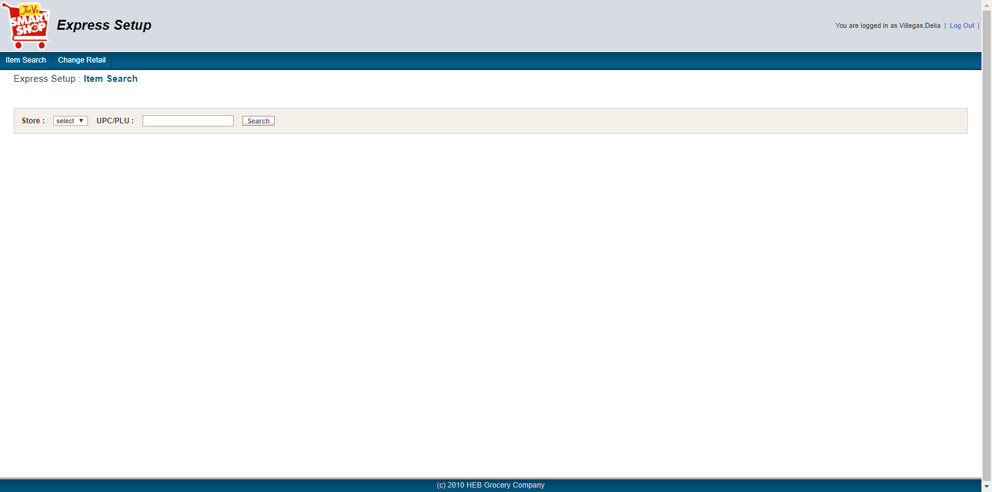

Figure 1. Item Search screen_default

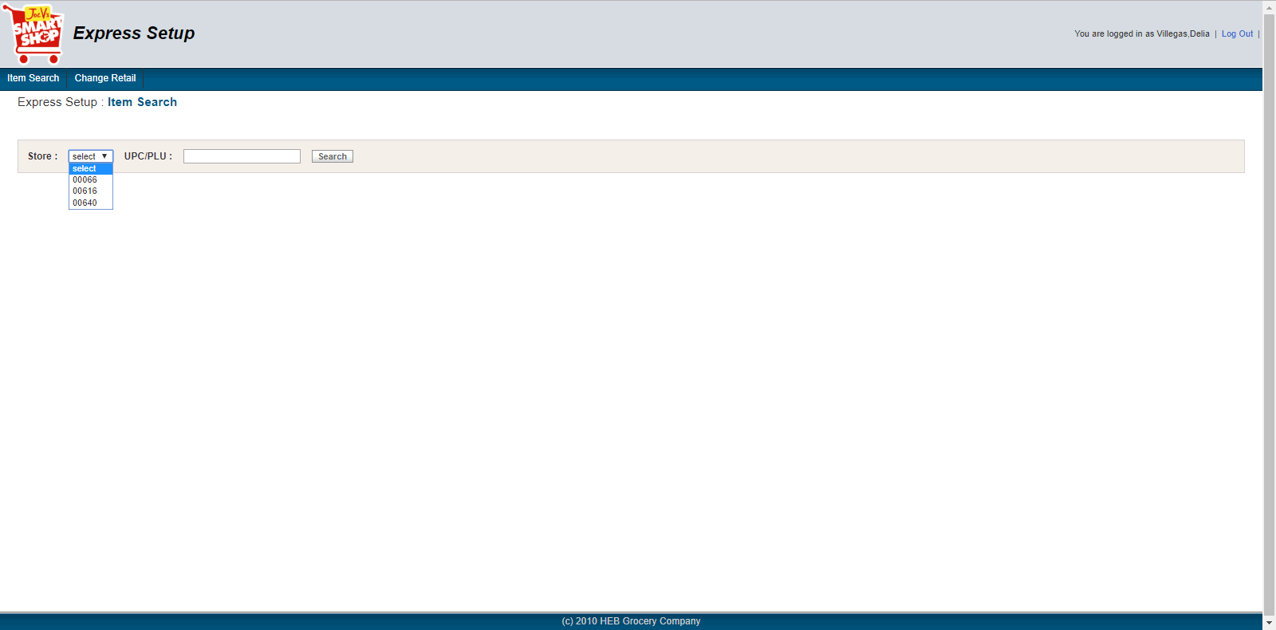

Figure 2. Item Search screen_List of Stores

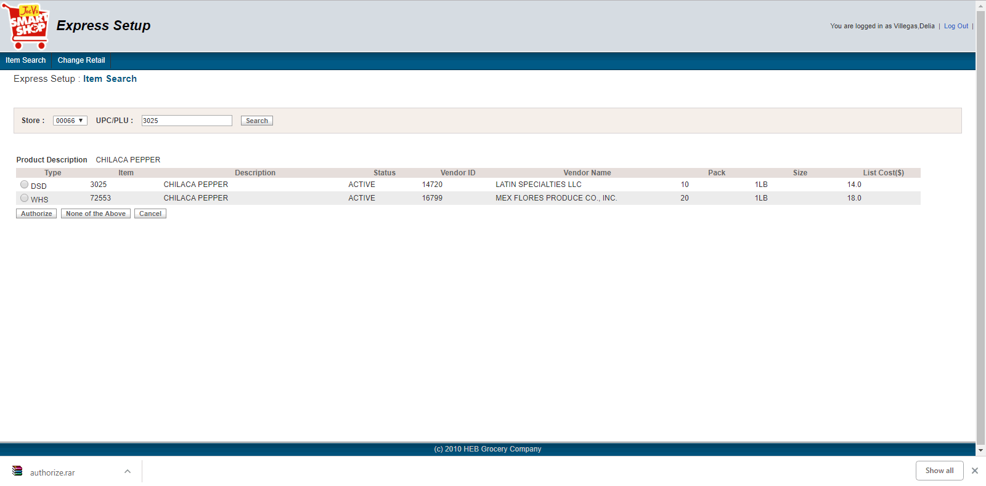

Figure 3. Item Search screen_Search result

### Business Rule

|  |  |  |
| --- | --- | --- |
| **Rule ID** | **Rule Description** | **Ref. figures** |
| 1 | Store drop-down: list of V.Joe store by default. | Figure 2 |
| 2 | User is able to search by one UPC/PLU each time | Figure 3 |
| 3 | When clicking "Search" return only the items that tied to Primary UPC that is associated to the entered UPC/PLU in the search box | Figure 3 |
|  | Search Item Query  **SELECT distinct**  im.itm_key_typ_cd, im.itm_id, im.item_des, im.dscon_dt, im.VAR_WT_SW, im.itm_sz_qty, im.itm_sz_uom_cd,  L.ap_nbr,l.loc_nm,  vl.vend_list_cst, vl.vend_pk_qty,  pm.str_dept_nbr, pm.str_sub_dept_id, pm.pss_dept_1,  pm.prod_prim_scn_id,  psc.scn_typ_cd,psc.PROD_ID,  gp.WT_SW  **FROM** item_master im, vend_loc_itm vl, location l, prod_scn_codes psc, GOODS_PROD gp  **WHERE** im.ordering_upc=(**SELECT** PD_UPC_NO from PD_ASSOCIATED_UPC **WHERE** PD_ASSOC_UPC_NO= <enter upc/plu>  **and** pm.PROD_ID = pi.PROD_ID  **and** pm.PROD_ID = psc.PROD_ID  **and** pm.prod_prim_scn_id = psc.scn_cd_id  **and** pi.ITM_ID = im.itm_id  **and** pi.itm_key_typ_cd = im.itm_key_typ_cd  **and** im.itm_id = vl.itm_id  **and** im.itm_key_typ_cd = vl.itm_key_typ_cd  **and** vl.vend_loc_nbr = l.loc_nbr  **and** vl.vend_loc_typ_cd = l.loc_typ_cd  **and** pm.PROD_ID=gp.PROD_ID and psc.PROD_ID= gp.PROD_ID and pi.PROD_ID = gp.PROD_ID  **and** l.INACTIVE_SW ='A' |  |
| 4 | If no item found from search  Then check if UPC was supplied by store id, ap vendor number and item code   * If apLocation.DsdSbbSw =’Y’ and vendorItemStore.AuthnSw = 'Y' then show the message ‘UPC was supplied by Scan Based Vendor.’ * Else, show following message “ 'UPC does not exist. Please use the button below to verify vendor', button "Verify Vendor" and button "Cancel" “ |  |
| 5 | The search result grid shows columns   * Item type   + Show **DSD** when Item type = ‘DSD’   + Otherwise show **WHS** * Item Id (item_master.itm_id), * Item description (item_master.item_des), * Status:   + Show Active:     - itemtype = DSD and discontinueDate after currentDate or discontinueDate == ‘1600-01-01’)     - Find whse_loc_itm by itemCode and Item type, if whse_loc_itm.SPLR_ITM_STATUS_CD =’ACTIV’ -> show Active.   + Show Inactive: otherwise * Vendor Id (location.ap_nbr) * Vendor Name (location.loc_nm) * Pack (vend_loc_itm.vend_pk_qty) * Size (itemMaster.ITM_SZ_QTY) * List cost (vend_loc_itm.vend_list_cst) | Figure 3 |
| 6 | Buttons shown after search   * “Authorize” button   + If AP_LOCATION.DSD_SBB_SW = Y AND vend_itm_str.AUTHN_SW = Y AND selected item not empty, will NOT show “Authorize” button * If AP_LOCATION.DSD_SBB_SW = N OR vend_itm_str.AUTHN_SW = N AND Selected item not empty, will show “Authorize” button * Clicking "Authorize" when an item is selected, navigate to Authorization screen * “None of the Above “ button * If selected item not empty, will show the None of the Above button. Else, not show the None of the Above button   + Clicking “None of the Above” navigate to Vendor Verification screen * “Cancel” button   + “Cancel” button is always displayed after search   + Clicking “Cancel” button clear the search criteria and search result | Figure 3 |
| 7 | User is able to select one item to authorize each time. |  |

## Item Search > Authorization screen

This is the screen when user clicks on “Authorize” button. This screen allows user to setup the details of item (DSD/WHS).

### Screen Reference

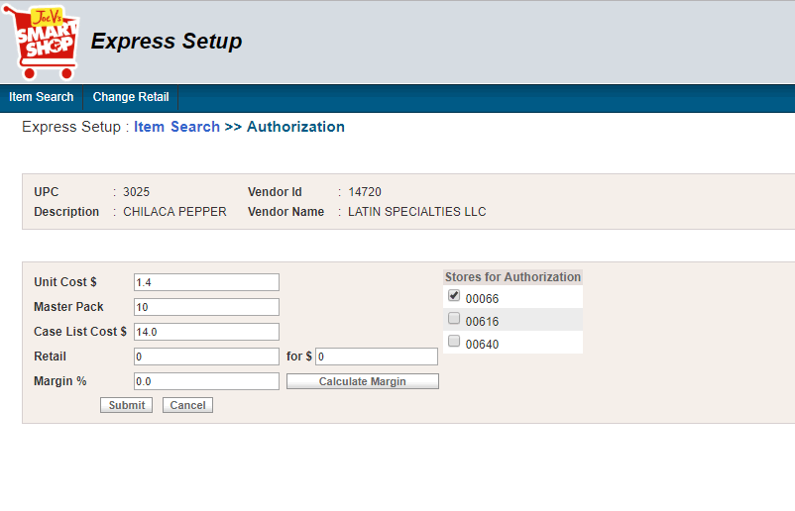

Figure 4. Authorization screen_Flex Weight = false

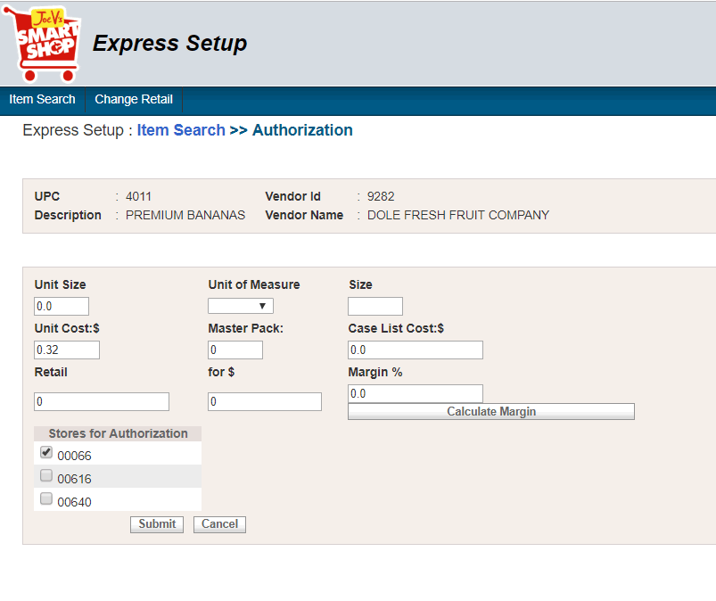

Figure 5. Authorization screen_Flex Weight = true

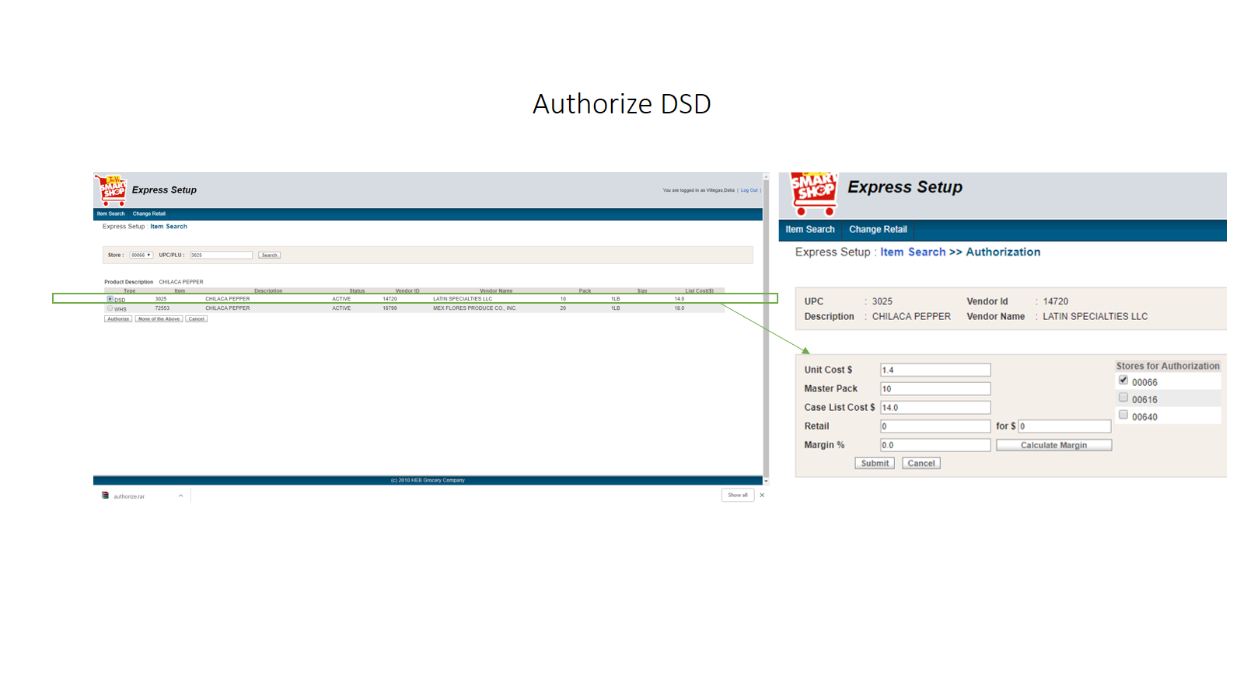

Figure 6. Authorize a DSD item

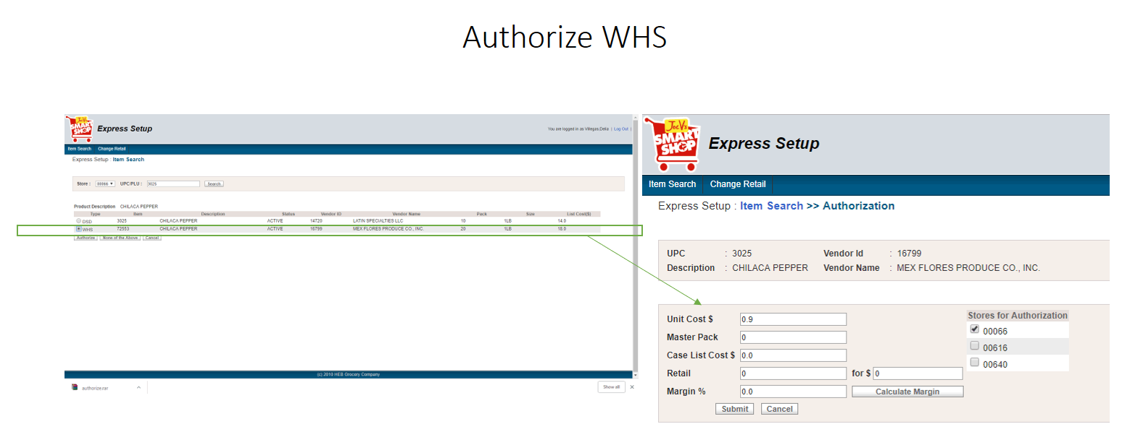

Figure 7. Authorize a WHS item

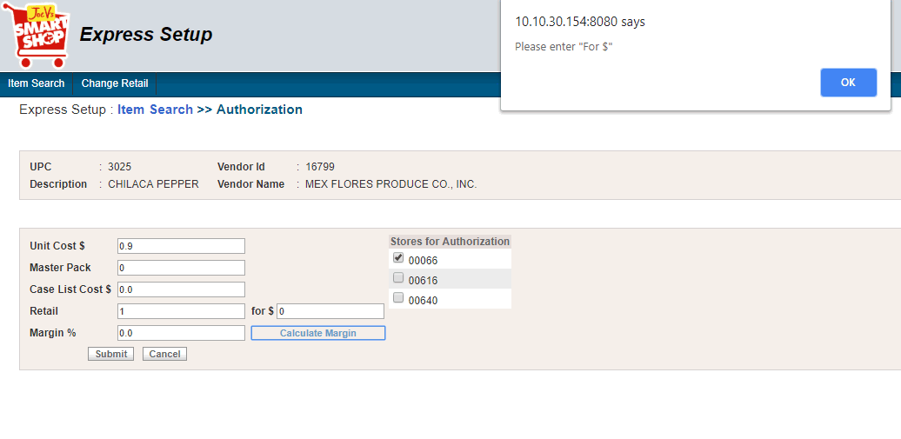

Figure 8. Authorization screen_Margin validation

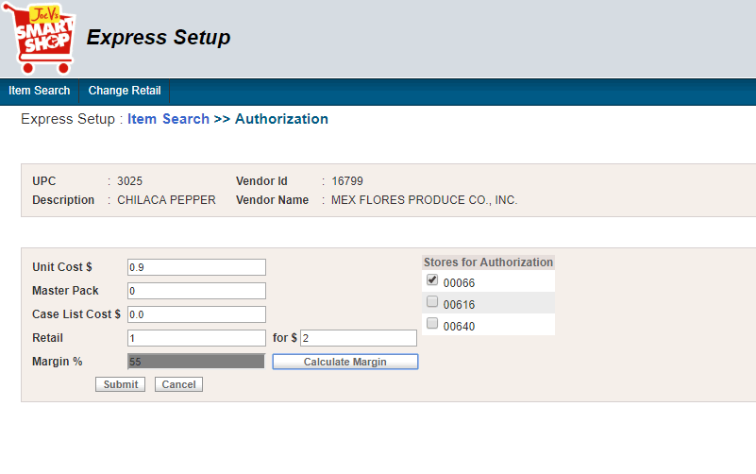

Figure 9. Authorization screen_Margin is calculated

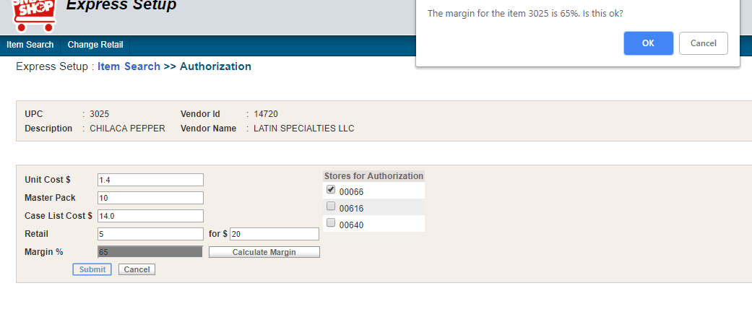

Figure 10. Authorization screen_Confirm message when submitting

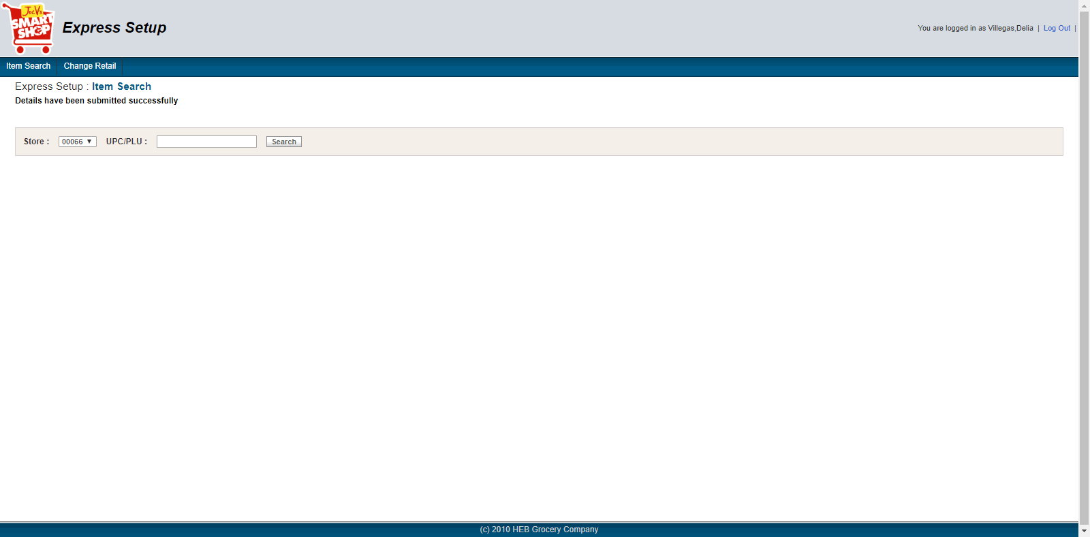

Figure 11. Authorization screen_Succesful message when submitting

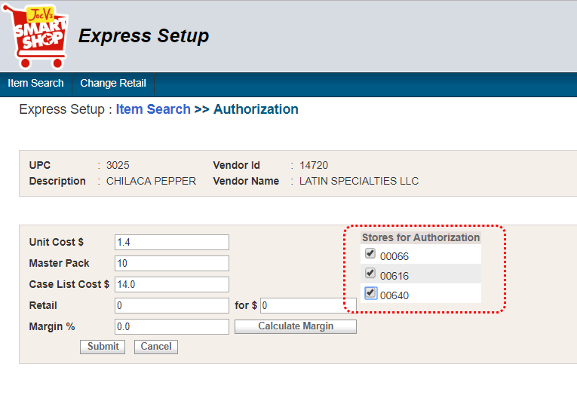

Figure 12. Authorization screen_Select more than 1 store

### Business Rule

|  |  |  |
| --- | --- | --- |
| **Rule ID** | **Rule Description** | **Ref. figures** |
| 1 | Authorize Item Forms   * Good Product ‘s WeightSwitch = true   The Authorization show fields   |  |  | | --- | --- | | **Field Name** | **Rule Description** | | Unit Size | Enter from UI. | | Unit of Measure | Show the list of ItemSizeUomCodes | | Size | is generated in the form Unit Size + Unit of Measure  (e.g. Unit Size = 10, Unit of Measure = CT --> Size = 10CT) | | Unit Cost:$ | List Cost / Pack (auto-filled, editable) | | Master Pack | For DSD item: Master Pack = Pack value on Item Search screen (editable)  For WHS item: Master Pack = 0 by default (editable) | | Case List Cost $ | Unit Cost * Master Pack (auto-filled, editable) | | Retail | empty by default, editable | | For $ | empty by default, editable | | Margin % | ((unitRetail- unitCost) / unitRetail) * 100  Note: unitRtl= xfor / rtlCst | | Store for authorization | List store authorization. (Editable) | | Submit button | Submit authorize item. |  * Good Product ‘s WeightSwitch = false   The Authorization show fields   |  |  | | --- | --- | | **Field Name** | **Rules Description** | | Unit Cost:$ | List Cost / Pack (auto-filled, editable) | | Master Pack | For DSD item: Master Pack = Pack value on Item Search screen (editable)  For WHS item: Master Pack = 0 by default (editable) | | Case List Cost:$ | Case List Cost $ = Unit Cost * Master Pack (auto-filled, editable) | | Retail | empty by default, editable | | For:$ | empty by default, editable | | Margin % | ((unitRetail- unitCost) / unitRetail) * 100  Note: unitRtl= xfor / rtlCst | | Store for authorization | List store authorization. (Editable) | | Submit button | Submit authorize item. | | Figure 4, 5, 6, 7 |
| 2 | Case List Cost $ requires Unit Cost, Master Pack |  |
| 3 | Margin % requires Unit Cost , Retail and For $ | Figure 8, 9 |
| 4 | User is able to select more than one store to authorize. Separated XML file will be sent to each selected store | Figure 12 |
| 5 | Clicking “Submit” show a message “The margin for the item [item id] is [margin value]%. Is this ok?” | Figure 10 |
| 6 | To submit authorization, all fields should be entered. Otherwise, an error message should be shown. |  |
| 7 | When the authorized is submitted successfully, a message “Details have been submitted successfully” should be shown. | Figure 11 |

### The generated XML file

This section includes

* Mapping authorize item
* What happens to the XML
* Sample picture and generated XML files when authorizing item (5 cases)

#### 2.3.1. Mapping authorize item

<?xml version="1.0" encoding="UTF-8" standalone="yes"?>

<MSG_Container xmlns="http://xmlns.heb.com/ei/G3" xmlns:ns2="http://xmlns.heb.com/ei/CDS_PROD_HIER" xmlns:ns4="http://xmlns.heb.com/ei/CDS_SCALE_REC" xmlns:ns3="http://xmlns.heb.com/ei/CDS_ITM_ID">

<Header>

<ProjectName>ItemAuthorization_ExpressSetup</ProjectName>

<Source_Domain>Application</Source_Domain>

<Destination_Domain></Destination_Domain>

<Transaction_Type>R7-ITEMAUTH</Transaction_Type>

<TimeStamp><!--current datetime with format: MM/dd/yyyy HH:mm:ss + TimeZoneId--></TimeStamp>

</Header>

<Body>

<G3_HOST_LAYOUT>

<G3_HDR_REC>

<G3_HDR_REC_CD>

<HD>HD</HD>

</G3_HDR_REC_CD>

<HDR_APLY_TYP_CD>1</HDR_APLY_TYP_CD>

<HDR_RSULT_PTR_CD>00</HDR_RSULT_PTR_CD>

<HDR_APLY_DT><!--current date with format: yyyy-MM-dd --></HDR_APLY_DT>

<HDR_APLY_TM><!--current time with format: HH:mm:ss--></HDR_APLY_TM>

<HDR_STR_NBR><!--Store id--></HDR_STR_NBR>

</G3_HDR_REC>

<G3_COMP>

<!--Setter for this section if "LOC_GRP_MEMBERS" is not exists data base on store id and vendor id and SPLR_LOC_TYP_CD='D' and CUST_LOC_TYP_CD='S'-->

<G3_VNDR_REC>

<G3_VNDR_REC_CD>

<SU>SU</SU>

</G3_VNDR_REC_CD>

<CRUD_CD>4</CRUD_CD>

<VNDR_RSULT_CD>00</VNDR_RSULT_CD>

<VNDR_VNDR_ID><!--ap_location.AP_NBR--></VNDR_VNDR_ID>

<VNDR_REC_FLAG>1</VNDR_REC_FLAG>

<VNDR_DUNN><!--ap_location.DSD_DBV_NBR--></VNDR_DUNN>

<VNDR_NM><!--ap_location.RMIT_CO_NM--></VNDR_NM>

<VNDR_ADD><!--ap_location.RMIT_ADR_1!=empty-> ap_location.RMIT_ADR_1--></VNDR_ADD>

<VNDR_CTY><!--ap_location.RMIT_ADR_2!=empty-> ap_location.RMIT_ADR_2--></VNDR_CTY>

<VNDR_STATE><!--ap_location.RMIT_ST--></VNDR_STATE>

<VNDR_REP><!--ap_location.CORR_CONTC_NM--></VNDR_REP>

<VNDR_ZIP><!--ap_location.RMIT_ZIP5_CD +''+ ap_location.RMIT_ZIP5_CD--></VNDR_ZIP>

<VNDR_PHN><!-- ap_location.RMIT_AREA_CD +''+ ap_location.RMIT_PHN_NBR--></VNDR_PHN>

<VNDR_TOT>0</VNDR_TOT>

<VNDR_DTL>1</VNDR_DTL>

<VNDR_STYLE>0</VNDR_STYLE>

<VNDR_DEPT><!--product_master.str_dept_nbr +''+ product_master.STR_SUB_DEPT_ID--></VNDR_DEPT>

<VNDR_COD><!--IF (ap_location.DSD_PROC_MODE='M' && ap_location.DSD_BNK_CD='1B') set = 1 ELSE set = 0--></VNDR_COD>

<VNDR_DSD>1</VNDR_DSD>

<VNDR_CHECKIN_METHD>1</VNDR_CHECKIN_METHD>

<VNDR_NEX_EVAL>1</VNDR_NEX_EVAL>

<VNDR_DEL_MISC_ALLOWNCES>1</VNDR_DEL_MISC_ALLOWNCES>

<VNDR_DEL_MISC_CHRGS>0</VNDR_DEL_MISC_CHRGS>

<VNDR_RET_MISC_CHRGS>0</VNDR_RET_MISC_CHRGS>

<VNDR_RET_MISC_ALLOWANCES>0</VNDR_RET_MISC_ALLOWANCES>

<VNDR_DUNN_LOC_CD><!--ap_location.DSD_DBV_LOC_CD--></VNDR_DUNN_LOC_CD>

<VNDR_RET_ONLY>0</VNDR_RET_ONLY>

</G3_VNDR_REC>

<G3_DEPT_REC>

<G3_DEPT_REC_CD>

<DP>DP</DP>

</G3_DEPT_REC_CD>

<CRUD_CD>4</CRUD_CD>

<DEPT_RSULT_CD>00</DEPT_RSULT_CD>

<DEPT_DEPT_NUMBER><!--product_master.str_dept_nbr +''+ product_master.STR_SUB_DEPT_ID--></DEPT_DEPT_NUMBER>

</G3_DEPT_REC>

<G3_CONSM_UNT_REC>

<G3_CU_REC_CD>

<IT>IT</IT>

</G3_CU_REC_CD>

<CRUD_CD>4</CRUD_CD>

<CU_RSULT_CD>00</CU_RSULT_CD>

<CU_UPC><!--prod_scn_codes.scn_cd_id--></CU_UPC>

<CU_ODR_CD>

<!-- IF(item_master.ITM_KEY_TYP_CD = 'DSD') Set = 0000000

ELSE set = item_master.ITM_ID-->

</CU_ODR_CD>

<CU_EFF_DT><!--Current date with format yyyy-MM-dd--></CU_EFF_DT>

<CU_TAG_CNTL_CD>0</CU_TAG_CNTL_CD>

<CU_EXT_DES><!--item_master.ITEM_DES--></CU_EXT_DES>

<CU_PACK_SZ><!--item_master.ITM_SZ_QTY PLUS item_master.itm_sz_uom_cd--></CU_PACK_SZ>

<ns2:CDS_PROD_HIER>

<ns2:DEPT_NBR><!--product_master.str_dept_nbr +''+ product_master.STR_SUB_DEPT_ID--></ns2:DEPT_NBR>

</ns2:CDS_PROD_HIER>

<CU_SCAN_PSS_DEPT><!--product_master.PSS_DEPT_1--></CU_SCAN_PSS_DEPT>

<CU_DES><!--item_master.ITEM_DES--></CU_DES>

<CU_TAX_SW><!-- IF goods_prod.SALS_TAX_SW = 'Y' set = 1 ELSE set = 0--></CU_TAX_SW>

<CU_FD_STMP><!--IF goods_prod.FD_STMP_SW ='Y' set = 1 ELSE set = 0--></CU_FD_STMP>

<CU_FAM_CD>0</CU_FAM_CD>

<CU_SCL_ITM_SW>

<!-- IF ((product_scan_code.SCN_TYP_CD ='PLU' && upc startWith ='002' && endWith ='00000') || goods_prod.WT_SW ='Y') set=0

ELSE set = 1-->

</CU_SCL_ITM_SW>

<CU_XFOR_QTY><!--Value from Retail field on Authorization Item form--></CU_XFOR_QTY>

<CU_RETL_PRC_AMT><!--Value from RetailFor field on Authorization Item form--></CU_RETL_PRC_AMT>

<CU_DSD_XFOR_QTY><!--Value from Retail field on Authorization Item form--></CU_DSD_XFOR_QTY>

<CU_DSD_PRC_AMT><!--Value from RetailFor field on Authorization Item form--></CU_DSD_PRC_AMT>

<CU_MXMAT_NUM>0</CU_MXMAT_NUM>

<CU_TAX_EXMT_AMT>0.00</CU_TAX_EXMT_AMT>

<CU_DSD_ITM_SW>1</CU_DSD_ITM_SW>

<CU_COUP_CD>N</CU_COUP_CD>

<CU_POS_ITM>1</CU_POS_ITM>

<CU_USR16>

<CU_OLD_PRC_AMT>0</CU_OLD_PRC_AMT>

</CU_USR16>

<CU_PROD_ID><!--prod_scn_codes.scn_cd_id--></CU_PROD_ID>

</G3_CONSM_UNT_REC>

<G3_PROD_REC>

<G3_PROD_REC_CD>

<SK>SK</SK>

</G3_PROD_REC_CD>

<CRUD_CD>4</CRUD_CD>

<PROD_RSULT_CD>00</PROD_RSULT_CD>

<ns3:CDS_ITM_ID>

<ns3:RETL_UNT_GTIN><!--prod_scn_codes.prod_id--></ns3:RETL_UNT_GTIN>

</ns3:CDS_ITM_ID>

<PROD_SKU_TYP_CD>M</PROD_SKU_TYP_CD>

<PROD_AUTH_SW>1</PROD_AUTH_SW>

<PROD_ACTV_SW>1</PROD_ACTV_SW>

<PROD_DISC_SW>0</PROD_DISC_SW>

<PROD_STAT_CD>00</PROD_STAT_CD>

<PROD_PRIM_UPC_ID><!--prod_scn_codes.scn_cd_id--></PROD_PRIM_UPC_ID>

<PROD_PRIM_DES><!--item_master.ITEM_DES--></PROD_PRIM_DES>

<PROD_DEPT_NBR>

<ns2:CDS_PROD_HIER>

<ns2:DEPT_NBR><!--product_master.str_dept_nbr +''+ product_master.STR_SUB_DEPT_ID--></ns2:DEPT_NBR>

</ns2:CDS_PROD_HIER>

</PROD_DEPT_NBR>

<PROD_VNDR_ID><!--ap_location.AP_NBR--></PROD_VNDR_ID>

<PROD_PACK_QTY><!--Value from MasterPack field on Authorization Item form--></PROD_PACK_QTY>

<PROD_REPT_CD>1</PROD_REPT_CD>

</G3_PROD_REC>

<G3_PK_REC>

<G3_PACK_REC_CD>

<PK>IT</PK>

</G3_PACK_REC_CD>

<CRUD_CD>4</CRUD_CD>

<PACK_RSULT_CD>00</PACK_RSULT_CD>

<PKG_PK_TYP_CD>I</PKG_PK_TYP_CD>

<PKG_CU_UPC><!--prod_scn_codes.scn_cd_id--></PKG_CU_UPC>

<CU_PK_QTY><!--Value from MasterPack field on Authorization Item form--></CU_PK_QTY>

</G3_PK_REC>

<G3_SPLR_PACK_REC>

<G3_SPLR_PK_REC_CD>

<SP>SP</SP>

</G3_SPLR_PK_REC_CD>

<CRUD_CD>4</CRUD_CD>

<SPLR_PK_RSULT_CD>00</SPLR_PK_RSULT_CD>

<SPLR_PK_ID>

<ns3:CDS_ITM_ID>

<ns3:RETL_UNT_GTIN><!--prod_scn_codes.scn_cd_id--></ns3:RETL_UNT_GTIN>

</ns3:CDS_ITM_ID>

</SPLR_PK_ID>

<SPLR_ITM_VNDR_NUM><!--ap_location.AP_NBR--></SPLR_ITM_VNDR_NUM>

<SPLR_PK_TYP_CD>I</SPLR_PK_TYP_CD>

<SPLR_PK_QTY><!--Value from MasterPack field on Authorization Item form--></SPLR_PK_QTY>

<SPLR_PK_ORD_CD>

<SPLR_ITM_VNDR_CD>1</SPLR_ITM_VNDR_CD>

</SPLR_PK_ORD_CD>

<SPLR_PK_PRIM_SW>0</SPLR_PK_PRIM_SW>

<SPLR_PK_RECV_AUTH_SW>1</SPLR_PK_RECV_AUTH_SW>

<SPLR_PK_CST><!--masterPack field multiplied by unitcost field on Authorization Item form--></SPLR_PK_CST>

</G3_SPLR_PACK_REC>

<!--Setter for this section if Item is Plu-->

<ns4:SCALE_REC>

<ns4:SCALE_HDR_REC>

<ns4:BATCH_NUMBER><!--Generate from log file--></ns4:BATCH_NUMBER>

<ns4:BATCH_DATE><!--Current date with format: yyyy-MM-dd--></ns4:BATCH_DATE>

<ns4:BATCH_TIME><!--Current time with format: HH:mm:ss--></ns4:BATCH_TIME>

<ns4:BATCH_EFFECTIVE_DATE><!--Current date with format: yyyy-MM-dd--></ns4:BATCH_EFFECTIVE_DATE>

<ns4:BATCH_EFFECTIVE_TIME><!--Current time with format: HH:mm:ss--></ns4:BATCH_EFFECTIVE_TIME>

<ns4:STORE_NUMBER><!--Store id on Authorization Item form--></ns4:STORE_NUMBER>

</ns4:SCALE_HDR_REC>

<ns4:SCALE_DTL_REC>

<ns4:SCALE_PK_REC_CD>

<ns4:SC>SC</ns4:SC>

</ns4:SCALE_PK_REC_CD>

<ns4:CRUD_CD>4</ns4:CRUD_CD>

<ns4:COMMAND_CODE>SPIC</ns4:COMMAND_CODE>

<ns4:STORE_NUMBER><!--Store id on Authorization Item form--></ns4:STORE_NUMBER>

<ns4:DEPARTMENT_NUMBER><!--product_master.str_dept_nbr +''+ product_master.STR_SUB_DEPT_ID--></ns4:DEPARTMENT_NUMBER>

<ns4:PLU_NO><!--prod_scn_codes.scn_cd_id--></ns4:PLU_NO>

<ns4:UPC_CODE><!--item_master.itm_Id--></ns4:UPC_CODE>

<ns4:DESC_ONE><!--'XS-'+item_master.item_des--></ns4:DESC_ONE>

<ns4:DESC_SIZE1><!-- hardcode = 5--></ns4:DESC_SIZE1>

<ns4:UNIT_PRICE><!--Value from UnitCost field on Authorization Item form--></ns4:UNIT_PRICE>

<ns4:SHELF_LIFE>1</ns4:SHELF_LIFE>

</ns4:SCALE_DTL_REC>

</ns4:SCALE_REC>

<!--End For Item Plu-->

</G3_COMP>

</G3_HOST_LAYOUT>

</Body>

</MSG_Container>

#### 2.3.2. What happens to the XML

|  |  |  |
| --- | --- | --- |
| **ID** | **Description** | **Ref. cases** |
| 1 | When authorizing an item, will set data, parse the java object to XML string and send it to POS and BI Queue.   * If authorize item of an UPC, application only send 1 xml * if authorize item of a PLU, application send 2 xml files (1 file PLU, 1 file for UPC of that PLU) * if authorize item to x stores, application send x xml files | Case 4,5  Case 3  Case 1 |
| 2 | There is no difference between doing authorization a DSD and a WHS. The generated xml files are the same. |  |
| 3 | The margin value will not be included in the generated xml. |  |

#### 2.3.3. Sample pictures and generated XML files when authorizing item (5 cases)

This section includes pictures and generated XML files matched with sample data in each picture when authorizing items in 5 cases.

case 1. Authorize item to multi store  
case 2. Check Vendor to Store  
case 3. Search by PLU  
case 4. Search by UPC, authorize a DSD item  
case 5. Search by UPC, authorize a WHS item

##### Case 1. Authorize item to multiple stores

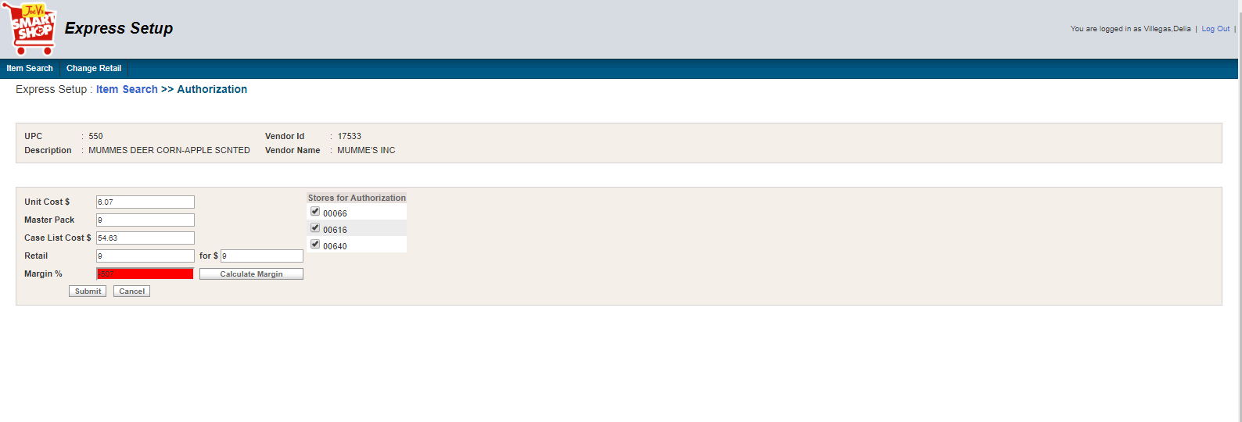

* **XML 1**

<?xml version="1.0" encoding="UTF-8"?>

<ns1:MSG_Container xmlns:ns1="http://xmlns.heb.com/ei/G3">

<ns1:Header>

<ns1:ProjectName>ItemAuthorization_ExpressSetup</ns1:ProjectName>

<ns1:Source_Domain>Application</ns1:Source_Domain>

<ns1:Destination_Domain />

<ns1:Transaction_Type>R7-ITEMAUTH</ns1:Transaction_Type>

<ns1:TimeStamp>09/19/2018 17:39:27Asia/Bangkok</ns1:TimeStamp>

</ns1:Header>

<ns1:Body>

<ns1:G3_HOST_LAYOUT>

<ns1:G3_HDR_REC>

<ns1:G3_HDR_REC_CD>

<ns1:HD>HD</ns1:HD>

</ns1:G3_HDR_REC_CD>

<ns1:HDR_APLY_TYP_CD>1</ns1:HDR_APLY_TYP_CD>

<ns1:HDR_RSULT_PTR_CD>00</ns1:HDR_RSULT_PTR_CD>

<ns1:HDR_APLY_DT>2018-09-19</ns1:HDR_APLY_DT>

<ns1:HDR_APLY_TM>17:39:27</ns1:HDR_APLY_TM>

<ns1:HDR_STR_NBR>00640</ns1:HDR_STR_NBR>

</ns1:G3_HDR_REC>

<ns1:G3_COMP>

<ns1:G3_VNDR_REC>

<ns1:G3_VNDR_REC_CD>

<ns1:SU>SU</ns1:SU>

</ns1:G3_VNDR_REC_CD>

<ns1:CRUD_CD>4</ns1:CRUD_CD>

<ns1:VNDR_RSULT_CD>00</ns1:VNDR_RSULT_CD>

<ns1:VNDR_VNDR_ID>17533</ns1:VNDR_VNDR_ID>

<ns1:VNDR_REC_FLAG>1</ns1:VNDR_REC_FLAG>

<ns1:VNDR_DUNN>0</ns1:VNDR_DUNN>

<ns1:VNDR_NM>MUMME'S INC</ns1:VNDR_NM>

<ns1:VNDR_ADD>PO BOX 369</ns1:VNDR_ADD>

<ns1:VNDR_STATE>TX</ns1:VNDR_STATE>

<ns1:VNDR_REP>-</ns1:VNDR_REP>

<ns1:VNDR_ZIP>78861369</ns1:VNDR_ZIP>

<ns1:VNDR_PHN>5122785676</ns1:VNDR_PHN>

<ns1:VNDR_TOT>0</ns1:VNDR_TOT>

<ns1:VNDR_DTL>1</ns1:VNDR_DTL>

<ns1:VNDR_STYLE>0</ns1:VNDR_STYLE>

<ns1:VNDR_DEPT>1201</ns1:VNDR_DEPT>

<ns1:VNDR_COD>0</ns1:VNDR_COD>

<ns1:VNDR_DSD>1</ns1:VNDR_DSD>

<ns1:VNDR_CHECKIN_METHD>1</ns1:VNDR_CHECKIN_METHD>

<ns1:VNDR_NEX_EVAL>1</ns1:VNDR_NEX_EVAL>

<ns1:VNDR_DEL_MISC_ALLOWNCES>1</ns1:VNDR_DEL_MISC_ALLOWNCES>

<ns1:VNDR_DEL_MISC_CHRGS>0</ns1:VNDR_DEL_MISC_CHRGS>

<ns1:VNDR_RET_MISC_CHRGS>0</ns1:VNDR_RET_MISC_CHRGS>

<ns1:VNDR_RET_MISC_ALLOWANCES>0</ns1:VNDR_RET_MISC_ALLOWANCES>

<ns1:VNDR_DUNN_LOC_CD>0</ns1:VNDR_DUNN_LOC_CD>

<ns1:VNDR_RET_ONLY>0</ns1:VNDR_RET_ONLY>

</ns1:G3_VNDR_REC>

<ns1:G3_DEPT_REC>

<ns1:G3_DEPT_REC_CD>

<ns1:DP>DP</ns1:DP>

</ns1:G3_DEPT_REC_CD>

<ns1:CRUD_CD>4</ns1:CRUD_CD>

<ns1:DEPT_RSULT_CD>00</ns1:DEPT_RSULT_CD>

<ns1:DEPT_DEPT_NUMBER>1201</ns1:DEPT_DEPT_NUMBER>

</ns1:G3_DEPT_REC>

<ns1:G3_CONSM_UNT_REC>

<ns1:G3_CU_REC_CD>

<ns1:IT>IT</ns1:IT>

</ns1:G3_CU_REC_CD>

<ns1:CRUD_CD>4</ns1:CRUD_CD>

<ns1:CU_RSULT_CD>00</ns1:CU_RSULT_CD>

<ns1:CU_UPC>550</ns1:CU_UPC>

<ns1:CU_ODR_CD>14337</ns1:CU_ODR_CD>

<ns1:CU_EFF_DT>2018-09-19</ns1:CU_EFF_DT>

<ns1:CU_TAG_CNTL_CD>0</ns1:CU_TAG_CNTL_CD>

<ns1:CU_EXT_DES>MUMMES DEER CORN-APPLE SCNTED</ns1:CU_EXT_DES>

<ns1:CU_PACK_SZ>50LB</ns1:CU_PACK_SZ>

<ns2:CDS_PROD_HIER xmlns:ns2="http://xmlns.heb.com/ei/CDS_PROD_HIER">

<ns2:DEPT_NBR>1201</ns2:DEPT_NBR>

</ns2:CDS_PROD_HIER>

<ns1:CU_SCAN_PSS_DEPT>92</ns1:CU_SCAN_PSS_DEPT>

<ns1:CU_DES>MUMMES DEER CORN-APPLE SCNTED</ns1:CU_DES>

<ns1:CU_TAX_SW>0</ns1:CU_TAX_SW>

<ns1:CU_FD_STMP>0</ns1:CU_FD_STMP>

<ns1:CU_FAM_CD>0</ns1:CU_FAM_CD>

<ns1:CU_SCL_ITM_SW>0</ns1:CU_SCL_ITM_SW>

<ns1:CU_XFOR_QTY>9</ns1:CU_XFOR_QTY>

<ns1:CU_RETL_PRC_AMT>9.0</ns1:CU_RETL_PRC_AMT>

<ns1:CU_DSD_XFOR_QTY>9</ns1:CU_DSD_XFOR_QTY>

<ns1:CU_DSD_PRC_AMT>9.0</ns1:CU_DSD_PRC_AMT>

<ns1:CU_MXMAT_NUM>0</ns1:CU_MXMAT_NUM>

<ns1:CU_TAX_EXMT_AMT>0.00</ns1:CU_TAX_EXMT_AMT>

<ns1:CU_DSD_ITM_SW>1</ns1:CU_DSD_ITM_SW>

<ns1:CU_COUP_CD>N</ns1:CU_COUP_CD>

<ns1:CU_POS_ITM>1</ns1:CU_POS_ITM>

<ns1:CU_USR16>

<ns1:CU_OLD_PRC_AMT>0</ns1:CU_OLD_PRC_AMT>

</ns1:CU_USR16>

<ns1:CU_PROD_ID>550</ns1:CU_PROD_ID>

</ns1:G3_CONSM_UNT_REC>

<ns1:G3_PROD_REC>

<ns1:G3_PROD_REC_CD>

<ns1:SK>SK</ns1:SK>

</ns1:G3_PROD_REC_CD>

<ns1:CRUD_CD>4</ns1:CRUD_CD>

<ns1:PROD_RSULT_CD>00</ns1:PROD_RSULT_CD>

<ns2:CDS_ITM_ID xmlns:ns2="http://xmlns.heb.com/ei/CDS_ITM_ID">

<ns2:RETL_UNT_GTIN>272362</ns2:RETL_UNT_GTIN>

</ns2:CDS_ITM_ID>

<ns1:PROD_SKU_TYP_CD>M</ns1:PROD_SKU_TYP_CD>

<ns1:PROD_AUTH_SW>1</ns1:PROD_AUTH_SW>

<ns1:PROD_ACTV_SW>1</ns1:PROD_ACTV_SW>

<ns1:PROD_DISC_SW>0</ns1:PROD_DISC_SW>

<ns1:PROD_STAT_CD>00</ns1:PROD_STAT_CD>

<ns1:PROD_PRIM_UPC_ID>550</ns1:PROD_PRIM_UPC_ID>

<ns1:PROD_PRIM_DES>MUMMES DEER CORN-APPLE SCNTED</ns1:PROD_PRIM_DES>

<ns1:PROD_DEPT_NBR>

<ns2:CDS_PROD_HIER xmlns:ns2="http://xmlns.heb.com/ei/CDS_PROD_HIER">

<ns2:DEPT_NBR>1201</ns2:DEPT_NBR>

</ns2:CDS_PROD_HIER>

</ns1:PROD_DEPT_NBR>

<ns1:PROD_VNDR_ID>17533</ns1:PROD_VNDR_ID>

<ns1:PROD_PACK_QTY>9</ns1:PROD_PACK_QTY>

<ns1:PROD_REPT_CD>1</ns1:PROD_REPT_CD>

</ns1:G3_PROD_REC>

<ns1:G3_PK_REC>

<ns1:G3_PACK_REC_CD>

<ns1:PK>IT</ns1:PK>

</ns1:G3_PACK_REC_CD>

<ns1:CRUD_CD>4</ns1:CRUD_CD>

<ns1:PACK_RSULT_CD>00</ns1:PACK_RSULT_CD>

<ns1:PKG_PK_TYP_CD>I</ns1:PKG_PK_TYP_CD>

<ns1:PKG_CU_UPC>550</ns1:PKG_CU_UPC>

<ns1:CU_PK_QTY>9</ns1:CU_PK_QTY>

</ns1:G3_PK_REC>

<ns1:G3_SPLR_PACK_REC>

<ns1:G3_SPLR_PK_REC_CD>

<ns1:SP>SP</ns1:SP>

</ns1:G3_SPLR_PK_REC_CD>

<ns1:CRUD_CD>4</ns1:CRUD_CD>

<ns1:SPLR_PK_RSULT_CD>00</ns1:SPLR_PK_RSULT_CD>

<ns1:SPLR_PK_ID>

<ns2:CDS_ITM_ID xmlns:ns2="http://xmlns.heb.com/ei/CDS_ITM_ID">

<ns2:RETL_UNT_GTIN>550</ns2:RETL_UNT_GTIN>

</ns2:CDS_ITM_ID>

</ns1:SPLR_PK_ID>

<ns1:SPLR_ITM_VNDR_NUM>17533</ns1:SPLR_ITM_VNDR_NUM>

<ns1:SPLR_PK_TYP_CD>I</ns1:SPLR_PK_TYP_CD>

<ns1:SPLR_PK_QTY>9</ns1:SPLR_PK_QTY>

<ns1:SPLR_PK_ORD_CD>

<ns1:SPLR_ITM_VNDR_CD>1</ns1:SPLR_ITM_VNDR_CD>

</ns1:SPLR_PK_ORD_CD>

<ns1:SPLR_PK_PRIM_SW>0</ns1:SPLR_PK_PRIM_SW>

<ns1:SPLR_PK_RECV_AUTH_SW>1</ns1:SPLR_PK_RECV_AUTH_SW>

<ns1:SPLR_PK_CST>54.63</ns1:SPLR_PK_CST>

</ns1:G3_SPLR_PACK_REC>

<ns2:SCALE_REC xmlns:ns2="http://xmlns.heb.com/ei/CDS_SCALE_REC" />

</ns1:G3_COMP>

</ns1:G3_HOST_LAYOUT>

</ns1:Body>

</ns1:MSG_Container>

* **XML 2**

<?xml version="1.0" encoding="UTF-8"?>

<ns1:MSG_Container xmlns:ns1="http://xmlns.heb.com/ei/G3">

<ns1:Header>

<ns1:ProjectName>ItemAuthorization_ExpressSetup</ns1:ProjectName>

<ns1:Source_Domain>Application</ns1:Source_Domain>

<ns1:Destination_Domain />

<ns1:Transaction_Type>R7-ITEMAUTH</ns1:Transaction_Type>

<ns1:TimeStamp>09/19/2018 17:39:27Asia/Bangkok</ns1:TimeStamp>

</ns1:Header>

<ns1:Body>

<ns1:G3_HOST_LAYOUT>

<ns1:G3_HDR_REC>

<ns1:G3_HDR_REC_CD>

<ns1:HD>HD</ns1:HD>

</ns1:G3_HDR_REC_CD>

<ns1:HDR_APLY_TYP_CD>1</ns1:HDR_APLY_TYP_CD>

<ns1:HDR_RSULT_PTR_CD>00</ns1:HDR_RSULT_PTR_CD>

<ns1:HDR_APLY_DT>2018-09-19</ns1:HDR_APLY_DT>

<ns1:HDR_APLY_TM>17:39:29</ns1:HDR_APLY_TM>

<ns1:HDR_STR_NBR>00616</ns1:HDR_STR_NBR>

</ns1:G3_HDR_REC>

<ns1:G3_COMP>

<ns1:G3_VNDR_REC>

<ns1:G3_VNDR_REC_CD>

<ns1:SU>SU</ns1:SU>

</ns1:G3_VNDR_REC_CD>

<ns1:CRUD_CD>4</ns1:CRUD_CD>

<ns1:VNDR_RSULT_CD>00</ns1:VNDR_RSULT_CD>

<ns1:VNDR_VNDR_ID>17533</ns1:VNDR_VNDR_ID>

<ns1:VNDR_REC_FLAG>1</ns1:VNDR_REC_FLAG>

<ns1:VNDR_DUNN>0</ns1:VNDR_DUNN>

<ns1:VNDR_NM>MUMME'S INC</ns1:VNDR_NM>

<ns1:VNDR_ADD>PO BOX 369</ns1:VNDR_ADD>

<ns1:VNDR_STATE>TX</ns1:VNDR_STATE>

<ns1:VNDR_REP>-</ns1:VNDR_REP>

<ns1:VNDR_ZIP>78861369</ns1:VNDR_ZIP>

<ns1:VNDR_PHN>5122785676</ns1:VNDR_PHN>

<ns1:VNDR_TOT>0</ns1:VNDR_TOT>

<ns1:VNDR_DTL>1</ns1:VNDR_DTL>

<ns1:VNDR_STYLE>0</ns1:VNDR_STYLE>

<ns1:VNDR_DEPT>1201</ns1:VNDR_DEPT>

<ns1:VNDR_COD>0</ns1:VNDR_COD>

<ns1:VNDR_DSD>1</ns1:VNDR_DSD>

<ns1:VNDR_CHECKIN_METHD>1</ns1:VNDR_CHECKIN_METHD>

<ns1:VNDR_NEX_EVAL>1</ns1:VNDR_NEX_EVAL>

<ns1:VNDR_DEL_MISC_ALLOWNCES>1</ns1:VNDR_DEL_MISC_ALLOWNCES>

<ns1:VNDR_DEL_MISC_CHRGS>0</ns1:VNDR_DEL_MISC_CHRGS>

<ns1:VNDR_RET_MISC_CHRGS>0</ns1:VNDR_RET_MISC_CHRGS>

<ns1:VNDR_RET_MISC_ALLOWANCES>0</ns1:VNDR_RET_MISC_ALLOWANCES>

<ns1:VNDR_DUNN_LOC_CD>0</ns1:VNDR_DUNN_LOC_CD>

<ns1:VNDR_RET_ONLY>0</ns1:VNDR_RET_ONLY>

</ns1:G3_VNDR_REC>

<ns1:G3_DEPT_REC>

<ns1:G3_DEPT_REC_CD>

<ns1:DP>DP</ns1:DP>

</ns1:G3_DEPT_REC_CD>

<ns1:CRUD_CD>4</ns1:CRUD_CD>

<ns1:DEPT_RSULT_CD>00</ns1:DEPT_RSULT_CD>

<ns1:DEPT_DEPT_NUMBER>1201</ns1:DEPT_DEPT_NUMBER>

</ns1:G3_DEPT_REC>

<ns1:G3_CONSM_UNT_REC>

<ns1:G3_CU_REC_CD>

<ns1:IT>IT</ns1:IT>

</ns1:G3_CU_REC_CD>

<ns1:CRUD_CD>4</ns1:CRUD_CD>

<ns1:CU_RSULT_CD>00</ns1:CU_RSULT_CD>

<ns1:CU_UPC>550</ns1:CU_UPC>

<ns1:CU_ODR_CD>14337</ns1:CU_ODR_CD>

<ns1:CU_EFF_DT>2018-09-19</ns1:CU_EFF_DT>

<ns1:CU_TAG_CNTL_CD>0</ns1:CU_TAG_CNTL_CD>

<ns1:CU_EXT_DES>MUMMES DEER CORN-APPLE SCNTED</ns1:CU_EXT_DES>

<ns1:CU_PACK_SZ>50LB</ns1:CU_PACK_SZ>

<ns2:CDS_PROD_HIER xmlns:ns2="http://xmlns.heb.com/ei/CDS_PROD_HIER">

<ns2:DEPT_NBR>1201</ns2:DEPT_NBR>

</ns2:CDS_PROD_HIER>

<ns1:CU_SCAN_PSS_DEPT>92</ns1:CU_SCAN_PSS_DEPT>

<ns1:CU_DES>MUMMES DEER CORN-APPLE SCNTED</ns1:CU_DES>

<ns1:CU_TAX_SW>0</ns1:CU_TAX_SW>

<ns1:CU_FD_STMP>0</ns1:CU_FD_STMP>

<ns1:CU_FAM_CD>0</ns1:CU_FAM_CD>

<ns1:CU_SCL_ITM_SW>0</ns1:CU_SCL_ITM_SW>

<ns1:CU_XFOR_QTY>9</ns1:CU_XFOR_QTY>

<ns1:CU_RETL_PRC_AMT>9.0</ns1:CU_RETL_PRC_AMT>

<ns1:CU_DSD_XFOR_QTY>9</ns1:CU_DSD_XFOR_QTY>

<ns1:CU_DSD_PRC_AMT>9.0</ns1:CU_DSD_PRC_AMT>

<ns1:CU_MXMAT_NUM>0</ns1:CU_MXMAT_NUM>

<ns1:CU_TAX_EXMT_AMT>0.00</ns1:CU_TAX_EXMT_AMT>

<ns1:CU_DSD_ITM_SW>1</ns1:CU_DSD_ITM_SW>

<ns1:CU_COUP_CD>N</ns1:CU_COUP_CD>

<ns1:CU_POS_ITM>1</ns1:CU_POS_ITM>

<ns1:CU_USR16>

<ns1:CU_OLD_PRC_AMT>0</ns1:CU_OLD_PRC_AMT>

</ns1:CU_USR16>

<ns1:CU_PROD_ID>550</ns1:CU_PROD_ID>

</ns1:G3_CONSM_UNT_REC>

<ns1:G3_PROD_REC>

<ns1:G3_PROD_REC_CD>

<ns1:SK>SK</ns1:SK>

</ns1:G3_PROD_REC_CD>

<ns1:CRUD_CD>4</ns1:CRUD_CD>

<ns1:PROD_RSULT_CD>00</ns1:PROD_RSULT_CD>

<ns2:CDS_ITM_ID xmlns:ns2="http://xmlns.heb.com/ei/CDS_ITM_ID">

<ns2:RETL_UNT_GTIN>272362</ns2:RETL_UNT_GTIN>

</ns2:CDS_ITM_ID>

<ns1:PROD_SKU_TYP_CD>M</ns1:PROD_SKU_TYP_CD>

<ns1:PROD_AUTH_SW>1</ns1:PROD_AUTH_SW>

<ns1:PROD_ACTV_SW>1</ns1:PROD_ACTV_SW>

<ns1:PROD_DISC_SW>0</ns1:PROD_DISC_SW>

<ns1:PROD_STAT_CD>00</ns1:PROD_STAT_CD>

<ns1:PROD_PRIM_UPC_ID>550</ns1:PROD_PRIM_UPC_ID>

<ns1:PROD_PRIM_DES>MUMMES DEER CORN-APPLE SCNTED</ns1:PROD_PRIM_DES>

<ns1:PROD_DEPT_NBR>

<ns2:CDS_PROD_HIER xmlns:ns2="http://xmlns.heb.com/ei/CDS_PROD_HIER">

<ns2:DEPT_NBR>1201</ns2:DEPT_NBR>

</ns2:CDS_PROD_HIER>

</ns1:PROD_DEPT_NBR>

<ns1:PROD_VNDR_ID>17533</ns1:PROD_VNDR_ID>

<ns1:PROD_PACK_QTY>9</ns1:PROD_PACK_QTY>

<ns1:PROD_REPT_CD>1</ns1:PROD_REPT_CD>

</ns1:G3_PROD_REC>

<ns1:G3_PK_REC>

<ns1:G3_PACK_REC_CD>

<ns1:PK>IT</ns1:PK>

</ns1:G3_PACK_REC_CD>

<ns1:CRUD_CD>4</ns1:CRUD_CD>

<ns1:PACK_RSULT_CD>00</ns1:PACK_RSULT_CD>

<ns1:PKG_PK_TYP_CD>I</ns1:PKG_PK_TYP_CD>

<ns1:PKG_CU_UPC>550</ns1:PKG_CU_UPC>

<ns1:CU_PK_QTY>9</ns1:CU_PK_QTY>

</ns1:G3_PK_REC>

<ns1:G3_SPLR_PACK_REC>

<ns1:G3_SPLR_PK_REC_CD>

<ns1:SP>SP</ns1:SP>

</ns1:G3_SPLR_PK_REC_CD>

<ns1:CRUD_CD>4</ns1:CRUD_CD>

<ns1:SPLR_PK_RSULT_CD>00</ns1:SPLR_PK_RSULT_CD>

<ns1:SPLR_PK_ID>

<ns2:CDS_ITM_ID xmlns:ns2="http://xmlns.heb.com/ei/CDS_ITM_ID">

<ns2:RETL_UNT_GTIN>550</ns2:RETL_UNT_GTIN>

</ns2:CDS_ITM_ID>

</ns1:SPLR_PK_ID>

<ns1:SPLR_ITM_VNDR_NUM>17533</ns1:SPLR_ITM_VNDR_NUM>

<ns1:SPLR_PK_TYP_CD>I</ns1:SPLR_PK_TYP_CD>

<ns1:SPLR_PK_QTY>9</ns1:SPLR_PK_QTY>

<ns1:SPLR_PK_ORD_CD>

<ns1:SPLR_ITM_VNDR_CD>1</ns1:SPLR_ITM_VNDR_CD>

</ns1:SPLR_PK_ORD_CD>

<ns1:SPLR_PK_PRIM_SW>0</ns1:SPLR_PK_PRIM_SW>

<ns1:SPLR_PK_RECV_AUTH_SW>1</ns1:SPLR_PK_RECV_AUTH_SW>

<ns1:SPLR_PK_CST>54.63</ns1:SPLR_PK_CST>

</ns1:G3_SPLR_PACK_REC>

<ns2:SCALE_REC xmlns:ns2="http://xmlns.heb.com/ei/CDS_SCALE_REC" />

</ns1:G3_COMP>

</ns1:G3_HOST_LAYOUT>

</ns1:Body>

</ns1:MSG_Container>

* **XML 3**

<?xml version="1.0" encoding="UTF-8"?>

<ns1:MSG_Container xmlns:ns1="http://xmlns.heb.com/ei/G3">

<ns1:Header>

<ns1:ProjectName>ItemAuthorization_ExpressSetup</ns1:ProjectName>

<ns1:Source_Domain>Application</ns1:Source_Domain>

<ns1:Destination_Domain />

<ns1:Transaction_Type>R7-ITEMAUTH</ns1:Transaction_Type>

<ns1:TimeStamp>09/19/2018 17:39:27Asia/Bangkok</ns1:TimeStamp>

</ns1:Header>

<ns1:Body>

<ns1:G3_HOST_LAYOUT>

<ns1:G3_HDR_REC>

<ns1:G3_HDR_REC_CD>

<ns1:HD>HD</ns1:HD>

</ns1:G3_HDR_REC_CD>

<ns1:HDR_APLY_TYP_CD>1</ns1:HDR_APLY_TYP_CD>

<ns1:HDR_RSULT_PTR_CD>00</ns1:HDR_RSULT_PTR_CD>

<ns1:HDR_APLY_DT>2018-09-19</ns1:HDR_APLY_DT>

<ns1:HDR_APLY_TM>17:39:31</ns1:HDR_APLY_TM>

<ns1:HDR_STR_NBR>00066</ns1:HDR_STR_NBR>

</ns1:G3_HDR_REC>

<ns1:G3_COMP>

<ns1:G3_VNDR_REC>

<ns1:G3_VNDR_REC_CD>

<ns1:SU>SU</ns1:SU>

</ns1:G3_VNDR_REC_CD>

<ns1:CRUD_CD>4</ns1:CRUD_CD>

<ns1:VNDR_RSULT_CD>00</ns1:VNDR_RSULT_CD>

<ns1:VNDR_VNDR_ID>17533</ns1:VNDR_VNDR_ID>

<ns1:VNDR_REC_FLAG>1</ns1:VNDR_REC_FLAG>

<ns1:VNDR_DUNN>0</ns1:VNDR_DUNN>

<ns1:VNDR_NM>MUMME'S INC</ns1:VNDR_NM>

<ns1:VNDR_ADD>PO BOX 369</ns1:VNDR_ADD>

<ns1:VNDR_STATE>TX</ns1:VNDR_STATE>

<ns1:VNDR_REP>-</ns1:VNDR_REP>

<ns1:VNDR_ZIP>78861369</ns1:VNDR_ZIP>

<ns1:VNDR_PHN>5122785676</ns1:VNDR_PHN>

<ns1:VNDR_TOT>0</ns1:VNDR_TOT>

<ns1:VNDR_DTL>1</ns1:VNDR_DTL>

<ns1:VNDR_STYLE>0</ns1:VNDR_STYLE>

<ns1:VNDR_DEPT>1201</ns1:VNDR_DEPT>

<ns1:VNDR_COD>0</ns1:VNDR_COD>

<ns1:VNDR_DSD>1</ns1:VNDR_DSD>

<ns1:VNDR_CHECKIN_METHD>1</ns1:VNDR_CHECKIN_METHD>

<ns1:VNDR_NEX_EVAL>1</ns1:VNDR_NEX_EVAL>

<ns1:VNDR_DEL_MISC_ALLOWNCES>1</ns1:VNDR_DEL_MISC_ALLOWNCES>

<ns1:VNDR_DEL_MISC_CHRGS>0</ns1:VNDR_DEL_MISC_CHRGS>

<ns1:VNDR_RET_MISC_CHRGS>0</ns1:VNDR_RET_MISC_CHRGS>

<ns1:VNDR_RET_MISC_ALLOWANCES>0</ns1:VNDR_RET_MISC_ALLOWANCES>

<ns1:VNDR_DUNN_LOC_CD>0</ns1:VNDR_DUNN_LOC_CD>

<ns1:VNDR_RET_ONLY>0</ns1:VNDR_RET_ONLY>

</ns1:G3_VNDR_REC>

<ns1:G3_DEPT_REC>

<ns1:G3_DEPT_REC_CD>

<ns1:DP>DP</ns1:DP>

</ns1:G3_DEPT_REC_CD>

<ns1:CRUD_CD>4</ns1:CRUD_CD>

<ns1:DEPT_RSULT_CD>00</ns1:DEPT_RSULT_CD>

<ns1:DEPT_DEPT_NUMBER>1201</ns1:DEPT_DEPT_NUMBER>

</ns1:G3_DEPT_REC>

<ns1:G3_CONSM_UNT_REC>

<ns1:G3_CU_REC_CD>

<ns1:IT>IT</ns1:IT>

</ns1:G3_CU_REC_CD>

<ns1:CRUD_CD>4</ns1:CRUD_CD>

<ns1:CU_RSULT_CD>00</ns1:CU_RSULT_CD>

<ns1:CU_UPC>550</ns1:CU_UPC>

<ns1:CU_ODR_CD>14337</ns1:CU_ODR_CD>

<ns1:CU_EFF_DT>2018-09-19</ns1:CU_EFF_DT>

<ns1:CU_TAG_CNTL_CD>0</ns1:CU_TAG_CNTL_CD>

<ns1:CU_EXT_DES>MUMMES DEER CORN-APPLE SCNTED</ns1:CU_EXT_DES>

<ns1:CU_PACK_SZ>50LB</ns1:CU_PACK_SZ>

<ns2:CDS_PROD_HIER xmlns:ns2="http://xmlns.heb.com/ei/CDS_PROD_HIER">

<ns2:DEPT_NBR>1201</ns2:DEPT_NBR>

</ns2:CDS_PROD_HIER>

<ns1:CU_SCAN_PSS_DEPT>92</ns1:CU_SCAN_PSS_DEPT>

<ns1:CU_DES>MUMMES DEER CORN-APPLE SCNTED</ns1:CU_DES>

<ns1:CU_TAX_SW>0</ns1:CU_TAX_SW>

<ns1:CU_FD_STMP>0</ns1:CU_FD_STMP>

<ns1:CU_FAM_CD>0</ns1:CU_FAM_CD>

<ns1:CU_SCL_ITM_SW>0</ns1:CU_SCL_ITM_SW>

<ns1:CU_XFOR_QTY>9</ns1:CU_XFOR_QTY>

<ns1:CU_RETL_PRC_AMT>9.0</ns1:CU_RETL_PRC_AMT>

<ns1:CU_DSD_XFOR_QTY>9</ns1:CU_DSD_XFOR_QTY>

<ns1:CU_DSD_PRC_AMT>9.0</ns1:CU_DSD_PRC_AMT>

<ns1:CU_MXMAT_NUM>0</ns1:CU_MXMAT_NUM>

<ns1:CU_TAX_EXMT_AMT>0.00</ns1:CU_TAX_EXMT_AMT>

<ns1:CU_DSD_ITM_SW>1</ns1:CU_DSD_ITM_SW>

<ns1:CU_COUP_CD>N</ns1:CU_COUP_CD>

<ns1:CU_POS_ITM>1</ns1:CU_POS_ITM>

<ns1:CU_USR16>

<ns1:CU_OLD_PRC_AMT>0</ns1:CU_OLD_PRC_AMT>

</ns1:CU_USR16>

<ns1:CU_PROD_ID>550</ns1:CU_PROD_ID>

</ns1:G3_CONSM_UNT_REC>

<ns1:G3_PROD_REC>

<ns1:G3_PROD_REC_CD>

<ns1:SK>SK</ns1:SK>

</ns1:G3_PROD_REC_CD>

<ns1:CRUD_CD>4</ns1:CRUD_CD>

<ns1:PROD_RSULT_CD>00</ns1:PROD_RSULT_CD>

<ns2:CDS_ITM_ID xmlns:ns2="http://xmlns.heb.com/ei/CDS_ITM_ID">

<ns2:RETL_UNT_GTIN>272362</ns2:RETL_UNT_GTIN>

</ns2:CDS_ITM_ID>

<ns1:PROD_SKU_TYP_CD>M</ns1:PROD_SKU_TYP_CD>

<ns1:PROD_AUTH_SW>1</ns1:PROD_AUTH_SW>

<ns1:PROD_ACTV_SW>1</ns1:PROD_ACTV_SW>

<ns1:PROD_DISC_SW>0</ns1:PROD_DISC_SW>

<ns1:PROD_STAT_CD>00</ns1:PROD_STAT_CD>

<ns1:PROD_PRIM_UPC_ID>550</ns1:PROD_PRIM_UPC_ID>

<ns1:PROD_PRIM_DES>MUMMES DEER CORN-APPLE SCNTED</ns1:PROD_PRIM_DES>

<ns1:PROD_DEPT_NBR>

<ns2:CDS_PROD_HIER xmlns:ns2="http://xmlns.heb.com/ei/CDS_PROD_HIER">

<ns2:DEPT_NBR>1201</ns2:DEPT_NBR>

</ns2:CDS_PROD_HIER>

</ns1:PROD_DEPT_NBR>

<ns1:PROD_VNDR_ID>17533</ns1:PROD_VNDR_ID>

<ns1:PROD_PACK_QTY>9</ns1:PROD_PACK_QTY>

<ns1:PROD_REPT_CD>1</ns1:PROD_REPT_CD>

</ns1:G3_PROD_REC>

<ns1:G3_PK_REC>

<ns1:G3_PACK_REC_CD>

<ns1:PK>IT</ns1:PK>

</ns1:G3_PACK_REC_CD>

<ns1:CRUD_CD>4</ns1:CRUD_CD>

<ns1:PACK_RSULT_CD>00</ns1:PACK_RSULT_CD>

<ns1:PKG_PK_TYP_CD>I</ns1:PKG_PK_TYP_CD>

<ns1:PKG_CU_UPC>550</ns1:PKG_CU_UPC>

<ns1:CU_PK_QTY>9</ns1:CU_PK_QTY>

</ns1:G3_PK_REC>

<ns1:G3_SPLR_PACK_REC>

<ns1:G3_SPLR_PK_REC_CD>

<ns1:SP>SP</ns1:SP>

</ns1:G3_SPLR_PK_REC_CD>

<ns1:CRUD_CD>4</ns1:CRUD_CD>

<ns1:SPLR_PK_RSULT_CD>00</ns1:SPLR_PK_RSULT_CD>

<ns1:SPLR_PK_ID>

<ns2:CDS_ITM_ID xmlns:ns2="http://xmlns.heb.com/ei/CDS_ITM_ID">

<ns2:RETL_UNT_GTIN>550</ns2:RETL_UNT_GTIN>

</ns2:CDS_ITM_ID>

</ns1:SPLR_PK_ID>

<ns1:SPLR_ITM_VNDR_NUM>17533</ns1:SPLR_ITM_VNDR_NUM>

<ns1:SPLR_PK_TYP_CD>I</ns1:SPLR_PK_TYP_CD>

<ns1:SPLR_PK_QTY>9</ns1:SPLR_PK_QTY>

<ns1:SPLR_PK_ORD_CD>

<ns1:SPLR_ITM_VNDR_CD>1</ns1:SPLR_ITM_VNDR_CD>

</ns1:SPLR_PK_ORD_CD>

<ns1:SPLR_PK_PRIM_SW>0</ns1:SPLR_PK_PRIM_SW>

<ns1:SPLR_PK_RECV_AUTH_SW>1</ns1:SPLR_PK_RECV_AUTH_SW>

<ns1:SPLR_PK_CST>54.63</ns1:SPLR_PK_CST>

</ns1:G3_SPLR_PACK_REC>

<ns2:SCALE_REC xmlns:ns2="http://xmlns.heb.com/ei/CDS_SCALE_REC" />

</ns1:G3_COMP>

</ns1:G3_HOST_LAYOUT>

</ns1:Body>

</ns1:MSG_Container>

##### Case 2. Check Vendor to Store

Steps:

1. query the relationship "vendor to store" existing on DB for vendor 9108558 and store 00066. (table LOC_GRP_MEMBERS)

2. try to authorize item 75395000069 belong to this vendor 9108558 to store 66

3. Node G3_VNDR_REC is set as empty in generated XML file

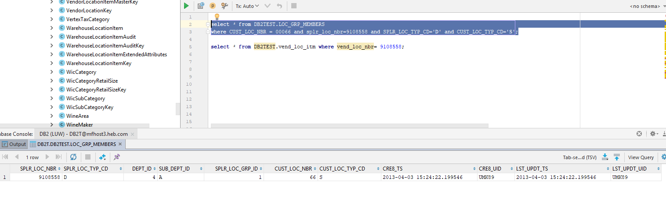

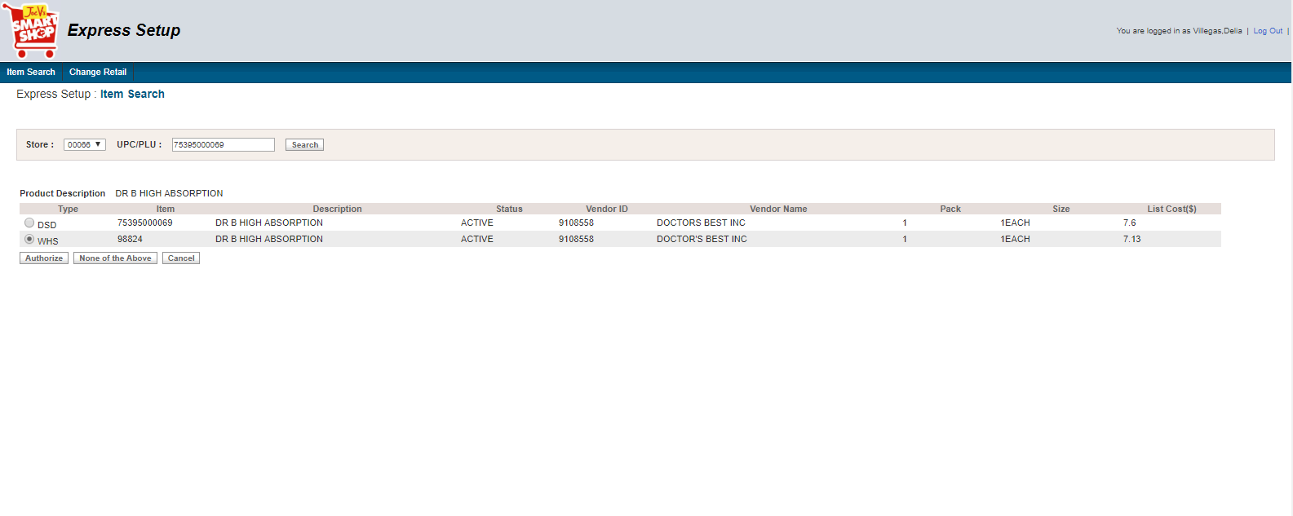

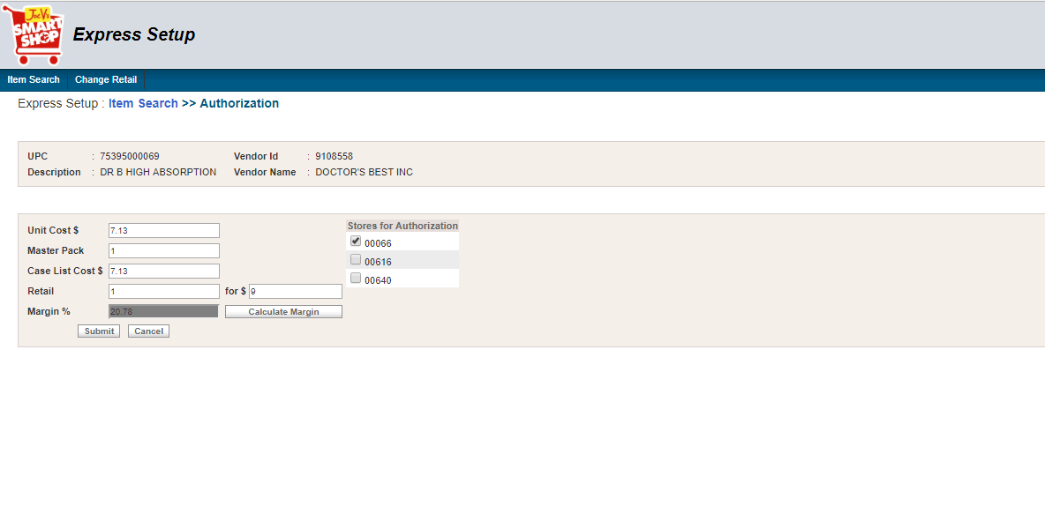

* **XML**

<?xml version="1.0" encoding="UTF-8"?>

<ns1:MSG_Container xmlns:ns1="http://xmlns.heb.com/ei/G3">

<ns1:Header>

<ns1:ProjectName>ItemAuthorization_ExpressSetup</ns1:ProjectName>

<ns1:Source_Domain>Application</ns1:Source_Domain>

<ns1:Destination_Domain />

<ns1:Transaction_Type>R7-ITEMAUTH</ns1:Transaction_Type>

<ns1:TimeStamp>09/19/2018 17:32:09Asia/Bangkok</ns1:TimeStamp>

</ns1:Header>

<ns1:Body>

<ns1:G3_HOST_LAYOUT>

<ns1:G3_HDR_REC>

<ns1:G3_HDR_REC_CD>

<ns1:HD>HD</ns1:HD>

</ns1:G3_HDR_REC_CD>

<ns1:HDR_APLY_TYP_CD>1</ns1:HDR_APLY_TYP_CD>

<ns1:HDR_RSULT_PTR_CD>00</ns1:HDR_RSULT_PTR_CD>

<ns1:HDR_APLY_DT>2018-09-19</ns1:HDR_APLY_DT>

<ns1:HDR_APLY_TM>17:32:09</ns1:HDR_APLY_TM>

<ns1:HDR_STR_NBR>00066</ns1:HDR_STR_NBR>

</ns1:G3_HDR_REC>

<ns1:G3_COMP>

<ns1:G3_VNDR_REC />

<ns1:G3_DEPT_REC>

<ns1:G3_DEPT_REC_CD>

<ns1:DP>DP</ns1:DP>

</ns1:G3_DEPT_REC_CD>

<ns1:CRUD_CD>4</ns1:CRUD_CD>

<ns1:DEPT_RSULT_CD>00</ns1:DEPT_RSULT_CD>

<ns1:DEPT_DEPT_NUMBER>0401</ns1:DEPT_DEPT_NUMBER>

</ns1:G3_DEPT_REC>

<ns1:G3_CONSM_UNT_REC>

<ns1:G3_CU_REC_CD>

<ns1:IT>IT</ns1:IT>

</ns1:G3_CU_REC_CD>

<ns1:CRUD_CD>4</ns1:CRUD_CD>

<ns1:CU_RSULT_CD>00</ns1:CU_RSULT_CD>

<ns1:CU_UPC>75395000069</ns1:CU_UPC>

<ns1:CU_ODR_CD>98824</ns1:CU_ODR_CD>

<ns1:CU_EFF_DT>2018-09-19</ns1:CU_EFF_DT>

<ns1:CU_TAG_CNTL_CD>0</ns1:CU_TAG_CNTL_CD>

<ns1:CU_EXT_DES>DR B HIGH ABSORPTION</ns1:CU_EXT_DES>

<ns1:CU_PACK_SZ>1EACH</ns1:CU_PACK_SZ>

<ns2:CDS_PROD_HIER xmlns:ns2="http://xmlns.heb.com/ei/CDS_PROD_HIER">

<ns2:DEPT_NBR>0401</ns2:DEPT_NBR>

</ns2:CDS_PROD_HIER>

<ns1:CU_SCAN_PSS_DEPT>30</ns1:CU_SCAN_PSS_DEPT>

<ns1:CU_DES>DR B HIGH ABSORPTION</ns1:CU_DES>

<ns1:CU_TAX_SW>0</ns1:CU_TAX_SW>

<ns1:CU_FD_STMP>0</ns1:CU_FD_STMP>

<ns1:CU_FAM_CD>0</ns1:CU_FAM_CD>

<ns1:CU_SCL_ITM_SW>0</ns1:CU_SCL_ITM_SW>

<ns1:CU_XFOR_QTY>1</ns1:CU_XFOR_QTY>

<ns1:CU_RETL_PRC_AMT>9.0</ns1:CU_RETL_PRC_AMT>

<ns1:CU_DSD_XFOR_QTY>1</ns1:CU_DSD_XFOR_QTY>

<ns1:CU_DSD_PRC_AMT>9.0</ns1:CU_DSD_PRC_AMT>

<ns1:CU_MXMAT_NUM>0</ns1:CU_MXMAT_NUM>

<ns1:CU_TAX_EXMT_AMT>0.00</ns1:CU_TAX_EXMT_AMT>

<ns1:CU_DSD_ITM_SW>1</ns1:CU_DSD_ITM_SW>

<ns1:CU_COUP_CD>N</ns1:CU_COUP_CD>

<ns1:CU_POS_ITM>1</ns1:CU_POS_ITM>

<ns1:CU_USR16>

<ns1:CU_OLD_PRC_AMT>0</ns1:CU_OLD_PRC_AMT>

</ns1:CU_USR16>

<ns1:CU_PROD_ID>75395000069</ns1:CU_PROD_ID>

</ns1:G3_CONSM_UNT_REC>

<ns1:G3_PROD_REC>

<ns1:G3_PROD_REC_CD>

<ns1:SK>SK</ns1:SK>

</ns1:G3_PROD_REC_CD>

<ns1:CRUD_CD>4</ns1:CRUD_CD>

<ns1:PROD_RSULT_CD>00</ns1:PROD_RSULT_CD>

<ns2:CDS_ITM_ID xmlns:ns2="http://xmlns.heb.com/ei/CDS_ITM_ID">

<ns2:RETL_UNT_GTIN>1493108</ns2:RETL_UNT_GTIN>

</ns2:CDS_ITM_ID>

<ns1:PROD_SKU_TYP_CD>M</ns1:PROD_SKU_TYP_CD>

<ns1:PROD_AUTH_SW>1</ns1:PROD_AUTH_SW>

<ns1:PROD_ACTV_SW>1</ns1:PROD_ACTV_SW>

<ns1:PROD_DISC_SW>0</ns1:PROD_DISC_SW>

<ns1:PROD_STAT_CD>00</ns1:PROD_STAT_CD>

<ns1:PROD_PRIM_UPC_ID>75395000069</ns1:PROD_PRIM_UPC_ID>

<ns1:PROD_PRIM_DES>DR B HIGH ABSORPTION</ns1:PROD_PRIM_DES>

<ns1:PROD_DEPT_NBR>

<ns2:CDS_PROD_HIER xmlns:ns2="http://xmlns.heb.com/ei/CDS_PROD_HIER">

<ns2:DEPT_NBR>0401</ns2:DEPT_NBR>

</ns2:CDS_PROD_HIER>

</ns1:PROD_DEPT_NBR>

<ns1:PROD_VNDR_ID>9108558</ns1:PROD_VNDR_ID>

<ns1:PROD_PACK_QTY>1</ns1:PROD_PACK_QTY>

<ns1:PROD_REPT_CD>1</ns1:PROD_REPT_CD>

</ns1:G3_PROD_REC>

<ns1:G3_PK_REC>

<ns1:G3_PACK_REC_CD>

<ns1:PK>IT</ns1:PK>

</ns1:G3_PACK_REC_CD>

<ns1:CRUD_CD>4</ns1:CRUD_CD>

<ns1:PACK_RSULT_CD>00</ns1:PACK_RSULT_CD>

<ns1:PKG_PK_TYP_CD>I</ns1:PKG_PK_TYP_CD>

<ns1:PKG_CU_UPC>75395000069</ns1:PKG_CU_UPC>

<ns1:CU_PK_QTY>1</ns1:CU_PK_QTY>

</ns1:G3_PK_REC>

<ns1:G3_SPLR_PACK_REC>

<ns1:G3_SPLR_PK_REC_CD>

<ns1:SP>SP</ns1:SP>

</ns1:G3_SPLR_PK_REC_CD>

<ns1:CRUD_CD>4</ns1:CRUD_CD>

<ns1:SPLR_PK_RSULT_CD>00</ns1:SPLR_PK_RSULT_CD>

<ns1:SPLR_PK_ID>

<ns2:CDS_ITM_ID xmlns:ns2="http://xmlns.heb.com/ei/CDS_ITM_ID">

<ns2:RETL_UNT_GTIN>75395000069</ns2:RETL_UNT_GTIN>

</ns2:CDS_ITM_ID>

</ns1:SPLR_PK_ID>

<ns1:SPLR_ITM_VNDR_NUM>9108558</ns1:SPLR_ITM_VNDR_NUM>

<ns1:SPLR_PK_TYP_CD>I</ns1:SPLR_PK_TYP_CD>

<ns1:SPLR_PK_QTY>1</ns1:SPLR_PK_QTY>

<ns1:SPLR_PK_ORD_CD>

<ns1:SPLR_ITM_VNDR_CD>1</ns1:SPLR_ITM_VNDR_CD>

</ns1:SPLR_PK_ORD_CD>

<ns1:SPLR_PK_PRIM_SW>0</ns1:SPLR_PK_PRIM_SW>

<ns1:SPLR_PK_RECV_AUTH_SW>1</ns1:SPLR_PK_RECV_AUTH_SW>

<ns1:SPLR_PK_CST>7.13</ns1:SPLR_PK_CST>

</ns1:G3_SPLR_PACK_REC>

<ns2:SCALE_REC xmlns:ns2="http://xmlns.heb.com/ei/CDS_SCALE_REC" />

</ns1:G3_COMP>

</ns1:G3_HOST_LAYOUT>

</ns1:Body>

</ns1:MSG_Container>

##### Case 3. Search by PLU

Search by PLU = 4021

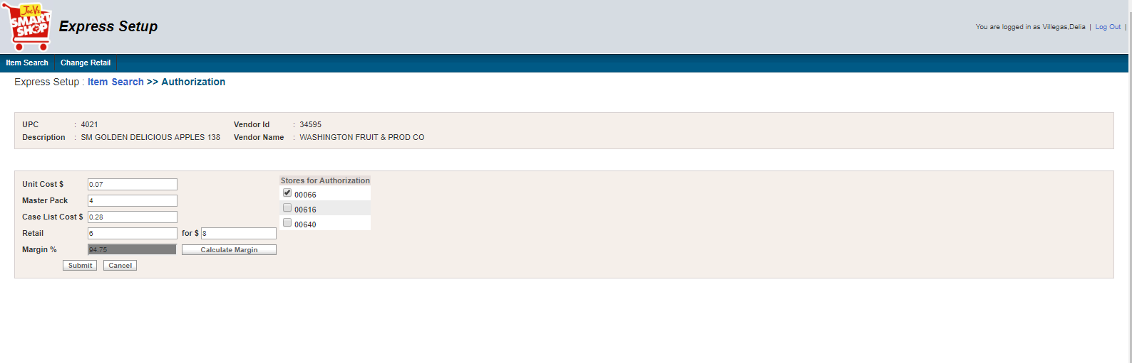

* **XML 1**

<?xml version="1.0" encoding="UTF-8"?>

<ns1:MSG_Container xmlns:ns1="http://xmlns.heb.com/ei/G3">

<ns1:Header>

<ns1:ProjectName>ItemAuthorization_ExpressSetup</ns1:ProjectName>

<ns1:Source_Domain>Application</ns1:Source_Domain>

<ns1:Destination_Domain />

<ns1:Transaction_Type>R7-ITEMAUTH</ns1:Transaction_Type>

<ns1:TimeStamp>09/19/2018 17:13:20Asia/Bangkok</ns1:TimeStamp>

</ns1:Header>

<ns1:Body>

<ns1:G3_HOST_LAYOUT>

<ns1:G3_HDR_REC>

<ns1:G3_HDR_REC_CD>

<ns1:HD>HD</ns1:HD>

</ns1:G3_HDR_REC_CD>

<ns1:HDR_APLY_TYP_CD>1</ns1:HDR_APLY_TYP_CD>

<ns1:HDR_RSULT_PTR_CD>00</ns1:HDR_RSULT_PTR_CD>

<ns1:HDR_APLY_DT>2018-09-19</ns1:HDR_APLY_DT>

<ns1:HDR_APLY_TM>17:13:20</ns1:HDR_APLY_TM>

<ns1:HDR_STR_NBR>00066</ns1:HDR_STR_NBR>

</ns1:G3_HDR_REC>

<ns1:G3_COMP>

<ns1:G3_VNDR_REC>

<ns1:G3_VNDR_REC_CD>

<ns1:SU>SU</ns1:SU>

</ns1:G3_VNDR_REC_CD>

<ns1:CRUD_CD>4</ns1:CRUD_CD>

<ns1:VNDR_RSULT_CD>00</ns1:VNDR_RSULT_CD>

<ns1:VNDR_VNDR_ID>34595</ns1:VNDR_VNDR_ID>

<ns1:VNDR_REC_FLAG>1</ns1:VNDR_REC_FLAG>

<ns1:VNDR_DUNN>0</ns1:VNDR_DUNN>

<ns1:VNDR_NM>WASHINGTON FRUIT AND PRODUCE</ns1:VNDR_NM>

<ns1:VNDR_ADD>PO BOX 1588</ns1:VNDR_ADD>

<ns1:VNDR_STATE>WA</ns1:VNDR_STATE>

<ns1:VNDR_REP>BILL GILMORE</ns1:VNDR_REP>

<ns1:VNDR_ZIP>989071588</ns1:VNDR_ZIP>

<ns1:VNDR_PHN>00</ns1:VNDR_PHN>

<ns1:VNDR_TOT>0</ns1:VNDR_TOT>

<ns1:VNDR_DTL>1</ns1:VNDR_DTL>

<ns1:VNDR_STYLE>0</ns1:VNDR_STYLE>

<ns1:VNDR_DEPT>0901</ns1:VNDR_DEPT>

<ns1:VNDR_COD>0</ns1:VNDR_COD>

<ns1:VNDR_DSD>1</ns1:VNDR_DSD>

<ns1:VNDR_CHECKIN_METHD>1</ns1:VNDR_CHECKIN_METHD>

<ns1:VNDR_NEX_EVAL>1</ns1:VNDR_NEX_EVAL>

<ns1:VNDR_DEL_MISC_ALLOWNCES>1</ns1:VNDR_DEL_MISC_ALLOWNCES>

<ns1:VNDR_DEL_MISC_CHRGS>0</ns1:VNDR_DEL_MISC_CHRGS>

<ns1:VNDR_RET_MISC_CHRGS>0</ns1:VNDR_RET_MISC_CHRGS>

<ns1:VNDR_RET_MISC_ALLOWANCES>0</ns1:VNDR_RET_MISC_ALLOWANCES>

<ns1:VNDR_DUNN_LOC_CD>0</ns1:VNDR_DUNN_LOC_CD>

<ns1:VNDR_RET_ONLY>0</ns1:VNDR_RET_ONLY>

</ns1:G3_VNDR_REC>

<ns1:G3_DEPT_REC>

<ns1:G3_DEPT_REC_CD>

<ns1:DP>DP</ns1:DP>

</ns1:G3_DEPT_REC_CD>

<ns1:CRUD_CD>4</ns1:CRUD_CD>

<ns1:DEPT_RSULT_CD>00</ns1:DEPT_RSULT_CD>

<ns1:DEPT_DEPT_NUMBER>0901</ns1:DEPT_DEPT_NUMBER>

</ns1:G3_DEPT_REC>

<ns1:G3_CONSM_UNT_REC>

<ns1:G3_CU_REC_CD>

<ns1:IT>IT</ns1:IT>

</ns1:G3_CU_REC_CD>

<ns1:CRUD_CD>4</ns1:CRUD_CD>

<ns1:CU_RSULT_CD>00</ns1:CU_RSULT_CD>

<ns1:CU_UPC>4021</ns1:CU_UPC>

<ns1:CU_ODR_CD>360644</ns1:CU_ODR_CD>

<ns1:CU_EFF_DT>2018-09-19</ns1:CU_EFF_DT>

<ns1:CU_TAG_CNTL_CD>0</ns1:CU_TAG_CNTL_CD>

<ns1:CU_EXT_DES>SM GOLDEN DELICIOUS APPLES 138</ns1:CU_EXT_DES>

<ns1:CU_PACK_SZ>1EACH</ns1:CU_PACK_SZ>

<ns2:CDS_PROD_HIER xmlns:ns2="http://xmlns.heb.com/ei/CDS_PROD_HIER">

<ns2:DEPT_NBR>0901</ns2:DEPT_NBR>

</ns2:CDS_PROD_HIER>

<ns1:CU_SCAN_PSS_DEPT>20</ns1:CU_SCAN_PSS_DEPT>

<ns1:CU_DES>SM GOLDEN DELICIOUS APPLES 138</ns1:CU_DES>

<ns1:CU_TAX_SW>0</ns1:CU_TAX_SW>

<ns1:CU_FD_STMP>1</ns1:CU_FD_STMP>

<ns1:CU_FAM_CD>0</ns1:CU_FAM_CD>

<ns1:CU_SCL_ITM_SW>1</ns1:CU_SCL_ITM_SW>

<ns1:CU_XFOR_QTY>6</ns1:CU_XFOR_QTY>

<ns1:CU_RETL_PRC_AMT>8.0</ns1:CU_RETL_PRC_AMT>

<ns1:CU_DSD_XFOR_QTY>6</ns1:CU_DSD_XFOR_QTY>

<ns1:CU_DSD_PRC_AMT>8.0</ns1:CU_DSD_PRC_AMT>

<ns1:CU_MXMAT_NUM>0</ns1:CU_MXMAT_NUM>

<ns1:CU_TAX_EXMT_AMT>0.00</ns1:CU_TAX_EXMT_AMT>

<ns1:CU_DSD_ITM_SW>1</ns1:CU_DSD_ITM_SW>

<ns1:CU_COUP_CD>N</ns1:CU_COUP_CD>

<ns1:CU_POS_ITM>1</ns1:CU_POS_ITM>

<ns1:CU_USR16>

<ns1:CU_OLD_PRC_AMT>0</ns1:CU_OLD_PRC_AMT>

</ns1:CU_USR16>

<ns1:CU_PROD_ID>4021</ns1:CU_PROD_ID>

</ns1:G3_CONSM_UNT_REC>

<ns1:G3_PROD_REC>

<ns1:G3_PROD_REC_CD>

<ns1:SK>SK</ns1:SK>

</ns1:G3_PROD_REC_CD>

<ns1:CRUD_CD>4</ns1:CRUD_CD>

<ns1:PROD_RSULT_CD>00</ns1:PROD_RSULT_CD>

<ns2:CDS_ITM_ID xmlns:ns2="http://xmlns.heb.com/ei/CDS_ITM_ID">

<ns2:RETL_UNT_GTIN>375135</ns2:RETL_UNT_GTIN>

</ns2:CDS_ITM_ID>

<ns1:PROD_SKU_TYP_CD>M</ns1:PROD_SKU_TYP_CD>

<ns1:PROD_AUTH_SW>1</ns1:PROD_AUTH_SW>

<ns1:PROD_ACTV_SW>1</ns1:PROD_ACTV_SW>

<ns1:PROD_DISC_SW>0</ns1:PROD_DISC_SW>

<ns1:PROD_STAT_CD>00</ns1:PROD_STAT_CD>

<ns1:PROD_PRIM_UPC_ID>4021</ns1:PROD_PRIM_UPC_ID>

<ns1:PROD_PRIM_DES>SM GOLDEN DELICIOUS APPLES 138</ns1:PROD_PRIM_DES>

<ns1:PROD_DEPT_NBR>

<ns2:CDS_PROD_HIER xmlns:ns2="http://xmlns.heb.com/ei/CDS_PROD_HIER">

<ns2:DEPT_NBR>0901</ns2:DEPT_NBR>

</ns2:CDS_PROD_HIER>

</ns1:PROD_DEPT_NBR>

<ns1:PROD_VNDR_ID>34595</ns1:PROD_VNDR_ID>

<ns1:PROD_PACK_QTY>4</ns1:PROD_PACK_QTY>

<ns1:PROD_REPT_CD>1</ns1:PROD_REPT_CD>

</ns1:G3_PROD_REC>

<ns1:G3_PK_REC>

<ns1:G3_PACK_REC_CD>

<ns1:PK>IT</ns1:PK>

</ns1:G3_PACK_REC_CD>

<ns1:CRUD_CD>4</ns1:CRUD_CD>

<ns1:PACK_RSULT_CD>00</ns1:PACK_RSULT_CD>

<ns1:PKG_PK_TYP_CD>I</ns1:PKG_PK_TYP_CD>

<ns1:PKG_CU_UPC>4021</ns1:PKG_CU_UPC>

<ns1:CU_PK_QTY>4</ns1:CU_PK_QTY>

</ns1:G3_PK_REC>

<ns1:G3_SPLR_PACK_REC>

<ns1:G3_SPLR_PK_REC_CD>

<ns1:SP>SP</ns1:SP>

</ns1:G3_SPLR_PK_REC_CD>

<ns1:CRUD_CD>4</ns1:CRUD_CD>

<ns1:SPLR_PK_RSULT_CD>00</ns1:SPLR_PK_RSULT_CD>

<ns1:SPLR_PK_ID>

<ns2:CDS_ITM_ID xmlns:ns2="http://xmlns.heb.com/ei/CDS_ITM_ID">

<ns2:RETL_UNT_GTIN>4021</ns2:RETL_UNT_GTIN>

</ns2:CDS_ITM_ID>

</ns1:SPLR_PK_ID>

<ns1:SPLR_ITM_VNDR_NUM>34595</ns1:SPLR_ITM_VNDR_NUM>

<ns1:SPLR_PK_TYP_CD>I</ns1:SPLR_PK_TYP_CD>

<ns1:SPLR_PK_QTY>4</ns1:SPLR_PK_QTY>

<ns1:SPLR_PK_ORD_CD>

<ns1:SPLR_ITM_VNDR_CD>1</ns1:SPLR_ITM_VNDR_CD>

</ns1:SPLR_PK_ORD_CD>

<ns1:SPLR_PK_PRIM_SW>0</ns1:SPLR_PK_PRIM_SW>

<ns1:SPLR_PK_RECV_AUTH_SW>1</ns1:SPLR_PK_RECV_AUTH_SW>

<ns1:SPLR_PK_CST>0.28</ns1:SPLR_PK_CST>

</ns1:G3_SPLR_PACK_REC>

<ns2:SCALE_REC xmlns:ns2="http://xmlns.heb.com/ei/CDS_SCALE_REC">

<ns2:SCALE_HDR_REC>

<ns2:BATCH_NUMBER>1026</ns2:BATCH_NUMBER>

<ns2:BATCH_DATE>2018-09-19</ns2:BATCH_DATE>

<ns2:BATCH_TIME>17:13:22</ns2:BATCH_TIME>

<ns2:BATCH_EFFECTIVE_DATE>2018-09-19</ns2:BATCH_EFFECTIVE_DATE>

<ns2:BATCH_EFFECTIVE_TIME>17:13:22</ns2:BATCH_EFFECTIVE_TIME>

<ns2:STORE_NUMBER>00066</ns2:STORE_NUMBER>

</ns2:SCALE_HDR_REC>

<ns2:SCALE_DTL_REC>

<ns2:SCALE_PK_REC_CD>

<ns2:SC>SC</ns2:SC>

</ns2:SCALE_PK_REC_CD>

<ns2:CRUD_CD>4</ns2:CRUD_CD>

<ns2:COMMAND_CODE>SPIC</ns2:COMMAND_CODE>

<ns2:STORE_NUMBER>00066</ns2:STORE_NUMBER>

<ns2:DEPARTMENT_NUMBER>0901</ns2:DEPARTMENT_NUMBER>

<ns2:PLU_NO>4021</ns2:PLU_NO>

<ns2:UPC_CODE>360644</ns2:UPC_CODE>

<ns2:DESC_ONE>XS-SM GOLDEN DELICIOUS APPLES 138</ns2:DESC_ONE>

<ns2:DESC_SIZE1>5</ns2:DESC_SIZE1>

<ns2:UNIT_PRICE>0.07</ns2:UNIT_PRICE>

<ns2:SHELF_LIFE>1</ns2:SHELF_LIFE>

</ns2:SCALE_DTL_REC>

</ns2:SCALE_REC>

</ns1:G3_COMP>

</ns1:G3_HOST_LAYOUT>

</ns1:Body>

</ns1:MSG_Container>

* **XML 2**

<?xml version="1.0" encoding="UTF-8"?>

<ns1:MSG_Container xmlns:ns1="http://xmlns.heb.com/ei/G3">

<ns1:Header>

<ns1:ProjectName>ItemAuthorization_ExpressSetup</ns1:ProjectName>

<ns1:Source_Domain>Application</ns1:Source_Domain>

<ns1:Destination_Domain />

<ns1:Transaction_Type>R7-ITEMAUTH</ns1:Transaction_Type>

<ns1:TimeStamp>09/19/2018 17:13:20Asia/Bangkok</ns1:TimeStamp>

</ns1:Header>

<ns1:Body>

<ns1:G3_HOST_LAYOUT>

<ns1:G3_HDR_REC>

<ns1:G3_HDR_REC_CD>

<ns1:HD>HD</ns1:HD>

</ns1:G3_HDR_REC_CD>

<ns1:HDR_APLY_TYP_CD>1</ns1:HDR_APLY_TYP_CD>

<ns1:HDR_RSULT_PTR_CD>00</ns1:HDR_RSULT_PTR_CD>

<ns1:HDR_APLY_DT>2018-09-19</ns1:HDR_APLY_DT>

<ns1:HDR_APLY_TM>17:13:22</ns1:HDR_APLY_TM>

<ns1:HDR_STR_NBR>00066</ns1:HDR_STR_NBR>

</ns1:G3_HDR_REC>

<ns1:G3_COMP>

<ns1:G3_VNDR_REC>

<ns1:G3_VNDR_REC_CD>

<ns1:SU>SU</ns1:SU>

</ns1:G3_VNDR_REC_CD>

<ns1:CRUD_CD>4</ns1:CRUD_CD>

<ns1:VNDR_RSULT_CD>00</ns1:VNDR_RSULT_CD>

<ns1:VNDR_VNDR_ID>34595</ns1:VNDR_VNDR_ID>

<ns1:VNDR_REC_FLAG>1</ns1:VNDR_REC_FLAG>

<ns1:VNDR_DUNN>0</ns1:VNDR_DUNN>

<ns1:VNDR_NM>WASHINGTON FRUIT AND PRODUCE</ns1:VNDR_NM>

<ns1:VNDR_ADD>PO BOX 1588</ns1:VNDR_ADD>

<ns1:VNDR_STATE>WA</ns1:VNDR_STATE>

<ns1:VNDR_REP>BILL GILMORE</ns1:VNDR_REP>

<ns1:VNDR_ZIP>989071588</ns1:VNDR_ZIP>

<ns1:VNDR_PHN>00</ns1:VNDR_PHN>

<ns1:VNDR_TOT>0</ns1:VNDR_TOT>

<ns1:VNDR_DTL>1</ns1:VNDR_DTL>

<ns1:VNDR_STYLE>0</ns1:VNDR_STYLE>

<ns1:VNDR_DEPT>0901</ns1:VNDR_DEPT>

<ns1:VNDR_COD>0</ns1:VNDR_COD>

<ns1:VNDR_DSD>1</ns1:VNDR_DSD>

<ns1:VNDR_CHECKIN_METHD>1</ns1:VNDR_CHECKIN_METHD>

<ns1:VNDR_NEX_EVAL>1</ns1:VNDR_NEX_EVAL>

<ns1:VNDR_DEL_MISC_ALLOWNCES>1</ns1:VNDR_DEL_MISC_ALLOWNCES>

<ns1:VNDR_DEL_MISC_CHRGS>0</ns1:VNDR_DEL_MISC_CHRGS>

<ns1:VNDR_RET_MISC_CHRGS>0</ns1:VNDR_RET_MISC_CHRGS>

<ns1:VNDR_RET_MISC_ALLOWANCES>0</ns1:VNDR_RET_MISC_ALLOWANCES>

<ns1:VNDR_DUNN_LOC_CD>0</ns1:VNDR_DUNN_LOC_CD>

<ns1:VNDR_RET_ONLY>0</ns1:VNDR_RET_ONLY>

</ns1:G3_VNDR_REC>

<ns1:G3_DEPT_REC>

<ns1:G3_DEPT_REC_CD>

<ns1:DP>DP</ns1:DP>

</ns1:G3_DEPT_REC_CD>

<ns1:CRUD_CD>4</ns1:CRUD_CD>

<ns1:DEPT_RSULT_CD>00</ns1:DEPT_RSULT_CD>

<ns1:DEPT_DEPT_NUMBER>0901</ns1:DEPT_DEPT_NUMBER>

</ns1:G3_DEPT_REC>

<ns1:G3_CONSM_UNT_REC>

<ns1:G3_CU_REC_CD>

<ns1:IT>IT</ns1:IT>

</ns1:G3_CU_REC_CD>

<ns1:CRUD_CD>4</ns1:CRUD_CD>

<ns1:CU_RSULT_CD>00</ns1:CU_RSULT_CD>

<ns1:CU_UPC>0020402100000</ns1:CU_UPC>

<ns1:CU_ODR_CD>360644</ns1:CU_ODR_CD>

<ns1:CU_EFF_DT>2018-09-19</ns1:CU_EFF_DT>

<ns1:CU_TAG_CNTL_CD>0</ns1:CU_TAG_CNTL_CD>

<ns1:CU_EXT_DES>SM GOLDEN DELICIOUS APPLES 138</ns1:CU_EXT_DES>

<ns1:CU_PACK_SZ>1EACH</ns1:CU_PACK_SZ>

<ns2:CDS_PROD_HIER xmlns:ns2="http://xmlns.heb.com/ei/CDS_PROD_HIER">

<ns2:DEPT_NBR>0901</ns2:DEPT_NBR>

</ns2:CDS_PROD_HIER>

<ns1:CU_SCAN_PSS_DEPT>20</ns1:CU_SCAN_PSS_DEPT>

<ns1:CU_DES>SM GOLDEN DELICIOUS APPLES 138</ns1:CU_DES>

<ns1:CU_TAX_SW>0</ns1:CU_TAX_SW>

<ns1:CU_FD_STMP>1</ns1:CU_FD_STMP>

<ns1:CU_FAM_CD>0</ns1:CU_FAM_CD>

<ns1:CU_SCL_ITM_SW>0</ns1:CU_SCL_ITM_SW>

<ns1:CU_XFOR_QTY>6</ns1:CU_XFOR_QTY>

<ns1:CU_RETL_PRC_AMT>8.0</ns1:CU_RETL_PRC_AMT>

<ns1:CU_DSD_XFOR_QTY>6</ns1:CU_DSD_XFOR_QTY>

<ns1:CU_DSD_PRC_AMT>8.0</ns1:CU_DSD_PRC_AMT>

<ns1:CU_MXMAT_NUM>0</ns1:CU_MXMAT_NUM>

<ns1:CU_TAX_EXMT_AMT>0.00</ns1:CU_TAX_EXMT_AMT>

<ns1:CU_DSD_ITM_SW>1</ns1:CU_DSD_ITM_SW>

<ns1:CU_COUP_CD>N</ns1:CU_COUP_CD>

<ns1:CU_POS_ITM>1</ns1:CU_POS_ITM>

<ns1:CU_USR16>

<ns1:CU_OLD_PRC_AMT>0</ns1:CU_OLD_PRC_AMT>

</ns1:CU_USR16>

<ns1:CU_PROD_ID>0020402100000</ns1:CU_PROD_ID>

</ns1:G3_CONSM_UNT_REC>

<ns1:G3_PROD_REC>

<ns1:G3_PROD_REC_CD>

<ns1:SK>SK</ns1:SK>

</ns1:G3_PROD_REC_CD>

<ns1:CRUD_CD>4</ns1:CRUD_CD>

<ns1:PROD_RSULT_CD>00</ns1:PROD_RSULT_CD>

<ns2:CDS_ITM_ID xmlns:ns2="http://xmlns.heb.com/ei/CDS_ITM_ID">

<ns2:RETL_UNT_GTIN>375135</ns2:RETL_UNT_GTIN>

</ns2:CDS_ITM_ID>

<ns1:PROD_SKU_TYP_CD>M</ns1:PROD_SKU_TYP_CD>

<ns1:PROD_AUTH_SW>1</ns1:PROD_AUTH_SW>

<ns1:PROD_ACTV_SW>1</ns1:PROD_ACTV_SW>

<ns1:PROD_DISC_SW>0</ns1:PROD_DISC_SW>

<ns1:PROD_STAT_CD>00</ns1:PROD_STAT_CD>

<ns1:PROD_PRIM_UPC_ID>0020402100000</ns1:PROD_PRIM_UPC_ID>

<ns1:PROD_PRIM_DES>SM GOLDEN DELICIOUS APPLES 138</ns1:PROD_PRIM_DES>

<ns1:PROD_DEPT_NBR>

<ns2:CDS_PROD_HIER xmlns:ns2="http://xmlns.heb.com/ei/CDS_PROD_HIER">

<ns2:DEPT_NBR>0901</ns2:DEPT_NBR>

</ns2:CDS_PROD_HIER>

</ns1:PROD_DEPT_NBR>

<ns1:PROD_VNDR_ID>34595</ns1:PROD_VNDR_ID>

<ns1:PROD_PACK_QTY>4</ns1:PROD_PACK_QTY>

<ns1:PROD_REPT_CD>1</ns1:PROD_REPT_CD>

</ns1:G3_PROD_REC>

<ns1:G3_PK_REC>

<ns1:G3_PACK_REC_CD>

<ns1:PK>IT</ns1:PK>

</ns1:G3_PACK_REC_CD>

<ns1:CRUD_CD>4</ns1:CRUD_CD>

<ns1:PACK_RSULT_CD>00</ns1:PACK_RSULT_CD>

<ns1:PKG_PK_TYP_CD>I</ns1:PKG_PK_TYP_CD>

<ns1:PKG_CU_UPC>0020402100000</ns1:PKG_CU_UPC>

<ns1:CU_PK_QTY>4</ns1:CU_PK_QTY>

</ns1:G3_PK_REC>

<ns1:G3_SPLR_PACK_REC>

<ns1:G3_SPLR_PK_REC_CD>

<ns1:SP>SP</ns1:SP>

</ns1:G3_SPLR_PK_REC_CD>

<ns1:CRUD_CD>4</ns1:CRUD_CD>

<ns1:SPLR_PK_RSULT_CD>00</ns1:SPLR_PK_RSULT_CD>

<ns1:SPLR_PK_ID>

<ns2:CDS_ITM_ID xmlns:ns2="http://xmlns.heb.com/ei/CDS_ITM_ID">

<ns2:RETL_UNT_GTIN>0020402100000</ns2:RETL_UNT_GTIN>

</ns2:CDS_ITM_ID>

</ns1:SPLR_PK_ID>

<ns1:SPLR_ITM_VNDR_NUM>34595</ns1:SPLR_ITM_VNDR_NUM>

<ns1:SPLR_PK_TYP_CD>I</ns1:SPLR_PK_TYP_CD>

<ns1:SPLR_PK_QTY>4</ns1:SPLR_PK_QTY>

<ns1:SPLR_PK_ORD_CD>

<ns1:SPLR_ITM_VNDR_CD>1</ns1:SPLR_ITM_VNDR_CD>

</ns1:SPLR_PK_ORD_CD>

<ns1:SPLR_PK_PRIM_SW>0</ns1:SPLR_PK_PRIM_SW>

<ns1:SPLR_PK_RECV_AUTH_SW>1</ns1:SPLR_PK_RECV_AUTH_SW>

<ns1:SPLR_PK_CST>0.28</ns1:SPLR_PK_CST>

</ns1:G3_SPLR_PACK_REC>

<ns2:SCALE_REC xmlns:ns2="http://xmlns.heb.com/ei/CDS_SCALE_REC">

<ns2:SCALE_HDR_REC>

<ns2:BATCH_NUMBER>1027</ns2:BATCH_NUMBER>

<ns2:BATCH_DATE>2018-09-19</ns2:BATCH_DATE>

<ns2:BATCH_TIME>17:13:24</ns2:BATCH_TIME>

<ns2:BATCH_EFFECTIVE_DATE>2018-09-19</ns2:BATCH_EFFECTIVE_DATE>

<ns2:BATCH_EFFECTIVE_TIME>17:13:24</ns2:BATCH_EFFECTIVE_TIME>

<ns2:STORE_NUMBER>00066</ns2:STORE_NUMBER>

</ns2:SCALE_HDR_REC>

<ns2:SCALE_DTL_REC>

<ns2:SCALE_PK_REC_CD>

<ns2:SC>SC</ns2:SC>

</ns2:SCALE_PK_REC_CD>

<ns2:CRUD_CD>4</ns2:CRUD_CD>

<ns2:COMMAND_CODE>SPIC</ns2:COMMAND_CODE>

<ns2:STORE_NUMBER>00066</ns2:STORE_NUMBER>

<ns2:DEPARTMENT_NUMBER>0901</ns2:DEPARTMENT_NUMBER>

<ns2:PLU_NO>0020402100000</ns2:PLU_NO>

<ns2:UPC_CODE>360644</ns2:UPC_CODE>

<ns2:DESC_ONE>XS-SM GOLDEN DELICIOUS APPLES 138</ns2:DESC_ONE>

<ns2:DESC_SIZE1>5</ns2:DESC_SIZE1>

<ns2:UNIT_PRICE>0.07</ns2:UNIT_PRICE>

<ns2:SHELF_LIFE>1</ns2:SHELF_LIFE>

</ns2:SCALE_DTL_REC>

</ns2:SCALE_REC>

</ns1:G3_COMP>

</ns1:G3_HOST_LAYOUT>

</ns1:Body>

</ns1:MSG_Container>

##### Case 4. Search by UPC, authorize a DSD item

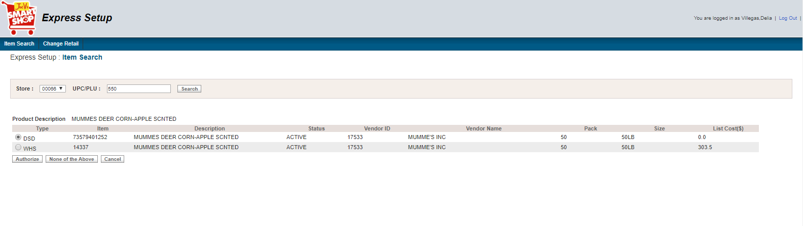

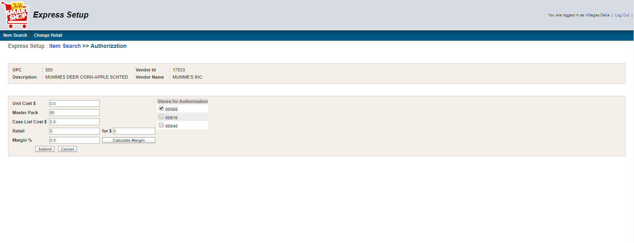

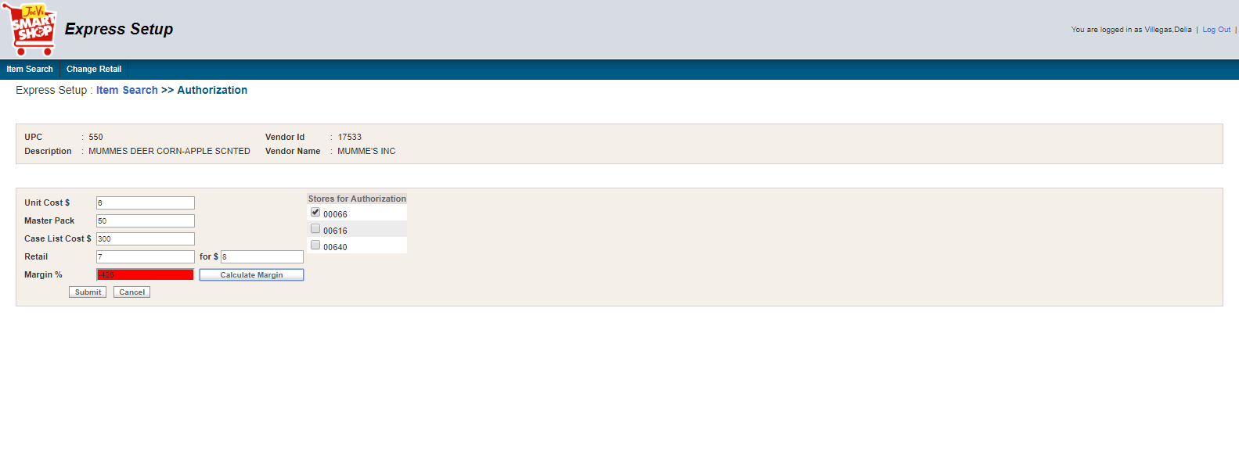

* **XML**

<?xml version="1.0" encoding="UTF-8"?>

<ns1:MSG_Container xmlns:ns1="http://xmlns.heb.com/ei/G3">

<ns1:Header>

<ns1:ProjectName>ItemAuthorization_ExpressSetup</ns1:ProjectName>

<ns1:Source_Domain>Application</ns1:Source_Domain>

<ns1:Destination_Domain />

<ns1:Transaction_Type>R7-ITEMAUTH</ns1:Transaction_Type>

<ns1:TimeStamp>09/19/2018 17:17:26Asia/Bangkok</ns1:TimeStamp>

</ns1:Header>

<ns1:Body>

<ns1:G3_HOST_LAYOUT>

<ns1:G3_HDR_REC>

<ns1:G3_HDR_REC_CD>

<ns1:HD>HD</ns1:HD>

</ns1:G3_HDR_REC_CD>

<ns1:HDR_APLY_TYP_CD>1</ns1:HDR_APLY_TYP_CD>

<ns1:HDR_RSULT_PTR_CD>00</ns1:HDR_RSULT_PTR_CD>

<ns1:HDR_APLY_DT>2018-09-19</ns1:HDR_APLY_DT>

<ns1:HDR_APLY_TM>17:17:26</ns1:HDR_APLY_TM>

<ns1:HDR_STR_NBR>00066</ns1:HDR_STR_NBR>

</ns1:G3_HDR_REC>

<ns1:G3_COMP>

<ns1:G3_VNDR_REC>

<ns1:G3_VNDR_REC_CD>

<ns1:SU>SU</ns1:SU>

</ns1:G3_VNDR_REC_CD>

<ns1:CRUD_CD>4</ns1:CRUD_CD>

<ns1:VNDR_RSULT_CD>00</ns1:VNDR_RSULT_CD>

<ns1:VNDR_VNDR_ID>17533</ns1:VNDR_VNDR_ID>

<ns1:VNDR_REC_FLAG>1</ns1:VNDR_REC_FLAG>

<ns1:VNDR_DUNN>0</ns1:VNDR_DUNN>

<ns1:VNDR_NM>MUMME'S INC</ns1:VNDR_NM>

<ns1:VNDR_ADD>PO BOX 369</ns1:VNDR_ADD>

<ns1:VNDR_STATE>TX</ns1:VNDR_STATE>

<ns1:VNDR_REP>-</ns1:VNDR_REP>

<ns1:VNDR_ZIP>78861369</ns1:VNDR_ZIP>

<ns1:VNDR_PHN>5122785676</ns1:VNDR_PHN>

<ns1:VNDR_TOT>0</ns1:VNDR_TOT>

<ns1:VNDR_DTL>1</ns1:VNDR_DTL>

<ns1:VNDR_STYLE>0</ns1:VNDR_STYLE>

<ns1:VNDR_DEPT>1201</ns1:VNDR_DEPT>

<ns1:VNDR_COD>0</ns1:VNDR_COD>

<ns1:VNDR_DSD>1</ns1:VNDR_DSD>

<ns1:VNDR_CHECKIN_METHD>1</ns1:VNDR_CHECKIN_METHD>

<ns1:VNDR_NEX_EVAL>1</ns1:VNDR_NEX_EVAL>

<ns1:VNDR_DEL_MISC_ALLOWNCES>1</ns1:VNDR_DEL_MISC_ALLOWNCES>

<ns1:VNDR_DEL_MISC_CHRGS>0</ns1:VNDR_DEL_MISC_CHRGS>

<ns1:VNDR_RET_MISC_CHRGS>0</ns1:VNDR_RET_MISC_CHRGS>

<ns1:VNDR_RET_MISC_ALLOWANCES>0</ns1:VNDR_RET_MISC_ALLOWANCES>

<ns1:VNDR_DUNN_LOC_CD>0</ns1:VNDR_DUNN_LOC_CD>

<ns1:VNDR_RET_ONLY>0</ns1:VNDR_RET_ONLY>

</ns1:G3_VNDR_REC>

<ns1:G3_DEPT_REC>

<ns1:G3_DEPT_REC_CD>

<ns1:DP>DP</ns1:DP>

</ns1:G3_DEPT_REC_CD>

<ns1:CRUD_CD>4</ns1:CRUD_CD>

<ns1:DEPT_RSULT_CD>00</ns1:DEPT_RSULT_CD>

<ns1:DEPT_DEPT_NUMBER>1201</ns1:DEPT_DEPT_NUMBER>

</ns1:G3_DEPT_REC>

<ns1:G3_CONSM_UNT_REC>

<ns1:G3_CU_REC_CD>

<ns1:IT>IT</ns1:IT>

</ns1:G3_CU_REC_CD>

<ns1:CRUD_CD>4</ns1:CRUD_CD>

<ns1:CU_RSULT_CD>00</ns1:CU_RSULT_CD>

<ns1:CU_UPC>550</ns1:CU_UPC>

<ns1:CU_ODR_CD>14337</ns1:CU_ODR_CD>

<ns1:CU_EFF_DT>2018-09-19</ns1:CU_EFF_DT>

<ns1:CU_TAG_CNTL_CD>0</ns1:CU_TAG_CNTL_CD>

<ns1:CU_EXT_DES>MUMMES DEER CORN-APPLE SCNTED</ns1:CU_EXT_DES>

<ns1:CU_PACK_SZ>50LB</ns1:CU_PACK_SZ>

<ns2:CDS_PROD_HIER xmlns:ns2="http://xmlns.heb.com/ei/CDS_PROD_HIER">

<ns2:DEPT_NBR>1201</ns2:DEPT_NBR>

</ns2:CDS_PROD_HIER>

<ns1:CU_SCAN_PSS_DEPT>92</ns1:CU_SCAN_PSS_DEPT>

<ns1:CU_DES>MUMMES DEER CORN-APPLE SCNTED</ns1:CU_DES>

<ns1:CU_TAX_SW>0</ns1:CU_TAX_SW>

<ns1:CU_FD_STMP>0</ns1:CU_FD_STMP>

<ns1:CU_FAM_CD>0</ns1:CU_FAM_CD>

<ns1:CU_SCL_ITM_SW>0</ns1:CU_SCL_ITM_SW>

<ns1:CU_XFOR_QTY>7</ns1:CU_XFOR_QTY>

<ns1:CU_RETL_PRC_AMT>8.0</ns1:CU_RETL_PRC_AMT>

<ns1:CU_DSD_XFOR_QTY>7</ns1:CU_DSD_XFOR_QTY>

<ns1:CU_DSD_PRC_AMT>8.0</ns1:CU_DSD_PRC_AMT>

<ns1:CU_MXMAT_NUM>0</ns1:CU_MXMAT_NUM>

<ns1:CU_TAX_EXMT_AMT>0.00</ns1:CU_TAX_EXMT_AMT>

<ns1:CU_DSD_ITM_SW>1</ns1:CU_DSD_ITM_SW>

<ns1:CU_COUP_CD>N</ns1:CU_COUP_CD>

<ns1:CU_POS_ITM>1</ns1:CU_POS_ITM>

<ns1:CU_USR16>

<ns1:CU_OLD_PRC_AMT>0</ns1:CU_OLD_PRC_AMT>

</ns1:CU_USR16>

<ns1:CU_PROD_ID>550</ns1:CU_PROD_ID>

</ns1:G3_CONSM_UNT_REC>

<ns1:G3_PROD_REC>

<ns1:G3_PROD_REC_CD>

<ns1:SK>SK</ns1:SK>

</ns1:G3_PROD_REC_CD>

<ns1:CRUD_CD>4</ns1:CRUD_CD>

<ns1:PROD_RSULT_CD>00</ns1:PROD_RSULT_CD>

<ns2:CDS_ITM_ID xmlns:ns2="http://xmlns.heb.com/ei/CDS_ITM_ID">

<ns2:RETL_UNT_GTIN>272362</ns2:RETL_UNT_GTIN>

</ns2:CDS_ITM_ID>

<ns1:PROD_SKU_TYP_CD>M</ns1:PROD_SKU_TYP_CD>

<ns1:PROD_AUTH_SW>1</ns1:PROD_AUTH_SW>

<ns1:PROD_ACTV_SW>1</ns1:PROD_ACTV_SW>

<ns1:PROD_DISC_SW>0</ns1:PROD_DISC_SW>

<ns1:PROD_STAT_CD>00</ns1:PROD_STAT_CD>

<ns1:PROD_PRIM_UPC_ID>550</ns1:PROD_PRIM_UPC_ID>

<ns1:PROD_PRIM_DES>MUMMES DEER CORN-APPLE SCNTED</ns1:PROD_PRIM_DES>

<ns1:PROD_DEPT_NBR>

<ns2:CDS_PROD_HIER xmlns:ns2="http://xmlns.heb.com/ei/CDS_PROD_HIER">

<ns2:DEPT_NBR>1201</ns2:DEPT_NBR>

</ns2:CDS_PROD_HIER>

</ns1:PROD_DEPT_NBR>

<ns1:PROD_VNDR_ID>17533</ns1:PROD_VNDR_ID>

<ns1:PROD_PACK_QTY>50</ns1:PROD_PACK_QTY>

<ns1:PROD_REPT_CD>1</ns1:PROD_REPT_CD>

</ns1:G3_PROD_REC>

<ns1:G3_PK_REC>

<ns1:G3_PACK_REC_CD>

<ns1:PK>IT</ns1:PK>

</ns1:G3_PACK_REC_CD>

<ns1:CRUD_CD>4</ns1:CRUD_CD>

<ns1:PACK_RSULT_CD>00</ns1:PACK_RSULT_CD>

<ns1:PKG_PK_TYP_CD>I</ns1:PKG_PK_TYP_CD>

<ns1:PKG_CU_UPC>550</ns1:PKG_CU_UPC>

<ns1:CU_PK_QTY>50</ns1:CU_PK_QTY>

</ns1:G3_PK_REC>

<ns1:G3_SPLR_PACK_REC>

<ns1:G3_SPLR_PK_REC_CD>

<ns1:SP>SP</ns1:SP>

</ns1:G3_SPLR_PK_REC_CD>

<ns1:CRUD_CD>4</ns1:CRUD_CD>

<ns1:SPLR_PK_RSULT_CD>00</ns1:SPLR_PK_RSULT_CD>

<ns1:SPLR_PK_ID>

<ns2:CDS_ITM_ID xmlns:ns2="http://xmlns.heb.com/ei/CDS_ITM_ID">

<ns2:RETL_UNT_GTIN>550</ns2:RETL_UNT_GTIN>

</ns2:CDS_ITM_ID>

</ns1:SPLR_PK_ID>

<ns1:SPLR_ITM_VNDR_NUM>17533</ns1:SPLR_ITM_VNDR_NUM>

<ns1:SPLR_PK_TYP_CD>I</ns1:SPLR_PK_TYP_CD>

<ns1:SPLR_PK_QTY>50</ns1:SPLR_PK_QTY>

<ns1:SPLR_PK_ORD_CD>

<ns1:SPLR_ITM_VNDR_CD>1</ns1:SPLR_ITM_VNDR_CD>

</ns1:SPLR_PK_ORD_CD>

<ns1:SPLR_PK_PRIM_SW>0</ns1:SPLR_PK_PRIM_SW>

<ns1:SPLR_PK_RECV_AUTH_SW>1</ns1:SPLR_PK_RECV_AUTH_SW>

<ns1:SPLR_PK_CST>300.0</ns1:SPLR_PK_CST>

</ns1:G3_SPLR_PACK_REC>

<ns2:SCALE_REC xmlns:ns2="http://xmlns.heb.com/ei/CDS_SCALE_REC" />

</ns1:G3_COMP>

</ns1:G3_HOST_LAYOUT>

</ns1:Body>

</ns1:MSG_Container>

##### Case 5. Search by UPC, authorize a WHS item

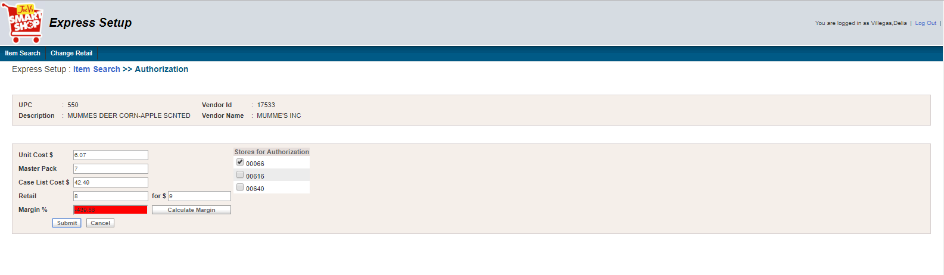

* **XML**

<?xml version="1.0" encoding="UTF-8"?>

<ns1:MSG_Container xmlns:ns1="http://xmlns.heb.com/ei/G3">

<ns1:Header>

<ns1:ProjectName>ItemAuthorization_ExpressSetup</ns1:ProjectName>

<ns1:Source_Domain>Application</ns1:Source_Domain>

<ns1:Destination_Domain />

<ns1:Transaction_Type>R7-ITEMAUTH</ns1:Transaction_Type>

<ns1:TimeStamp>09/19/2018 17:19:35Asia/Bangkok</ns1:TimeStamp>

</ns1:Header>

<ns1:Body>

<ns1:G3_HOST_LAYOUT>

<ns1:G3_HDR_REC>

<ns1:G3_HDR_REC_CD>

<ns1:HD>HD</ns1:HD>

</ns1:G3_HDR_REC_CD>

<ns1:HDR_APLY_TYP_CD>1</ns1:HDR_APLY_TYP_CD>

<ns1:HDR_RSULT_PTR_CD>00</ns1:HDR_RSULT_PTR_CD>

<ns1:HDR_APLY_DT>2018-09-19</ns1:HDR_APLY_DT>

<ns1:HDR_APLY_TM>17:19:35</ns1:HDR_APLY_TM>

<ns1:HDR_STR_NBR>00066</ns1:HDR_STR_NBR>

</ns1:G3_HDR_REC>

<ns1:G3_COMP>

<ns1:G3_VNDR_REC>

<ns1:G3_VNDR_REC_CD>

<ns1:SU>SU</ns1:SU>

</ns1:G3_VNDR_REC_CD>

<ns1:CRUD_CD>4</ns1:CRUD_CD>

<ns1:VNDR_RSULT_CD>00</ns1:VNDR_RSULT_CD>

<ns1:VNDR_VNDR_ID>17533</ns1:VNDR_VNDR_ID>

<ns1:VNDR_REC_FLAG>1</ns1:VNDR_REC_FLAG>

<ns1:VNDR_DUNN>0</ns1:VNDR_DUNN>

<ns1:VNDR_NM>MUMME'S INC</ns1:VNDR_NM>

<ns1:VNDR_ADD>PO BOX 369</ns1:VNDR_ADD>

<ns1:VNDR_STATE>TX</ns1:VNDR_STATE>

<ns1:VNDR_REP>-</ns1:VNDR_REP>

<ns1:VNDR_ZIP>78861369</ns1:VNDR_ZIP>

<ns1:VNDR_PHN>5122785676</ns1:VNDR_PHN>

<ns1:VNDR_TOT>0</ns1:VNDR_TOT>

<ns1:VNDR_DTL>1</ns1:VNDR_DTL>

<ns1:VNDR_STYLE>0</ns1:VNDR_STYLE>

<ns1:VNDR_DEPT>1201</ns1:VNDR_DEPT>

<ns1:VNDR_COD>0</ns1:VNDR_COD>

<ns1:VNDR_DSD>1</ns1:VNDR_DSD>

<ns1:VNDR_CHECKIN_METHD>1</ns1:VNDR_CHECKIN_METHD>

<ns1:VNDR_NEX_EVAL>1</ns1:VNDR_NEX_EVAL>

<ns1:VNDR_DEL_MISC_ALLOWNCES>1</ns1:VNDR_DEL_MISC_ALLOWNCES>

<ns1:VNDR_DEL_MISC_CHRGS>0</ns1:VNDR_DEL_MISC_CHRGS>

<ns1:VNDR_RET_MISC_CHRGS>0</ns1:VNDR_RET_MISC_CHRGS>

<ns1:VNDR_RET_MISC_ALLOWANCES>0</ns1:VNDR_RET_MISC_ALLOWANCES>

<ns1:VNDR_DUNN_LOC_CD>0</ns1:VNDR_DUNN_LOC_CD>

<ns1:VNDR_RET_ONLY>0</ns1:VNDR_RET_ONLY>

</ns1:G3_VNDR_REC>

<ns1:G3_DEPT_REC>

<ns1:G3_DEPT_REC_CD>

<ns1:DP>DP</ns1:DP>

</ns1:G3_DEPT_REC_CD>

<ns1:CRUD_CD>4</ns1:CRUD_CD>

<ns1:DEPT_RSULT_CD>00</ns1:DEPT_RSULT_CD>

<ns1:DEPT_DEPT_NUMBER>1201</ns1:DEPT_DEPT_NUMBER>

</ns1:G3_DEPT_REC>

<ns1:G3_CONSM_UNT_REC>

<ns1:G3_CU_REC_CD>

<ns1:IT>IT</ns1:IT>

</ns1:G3_CU_REC_CD>

<ns1:CRUD_CD>4</ns1:CRUD_CD>

<ns1:CU_RSULT_CD>00</ns1:CU_RSULT_CD>

<ns1:CU_UPC>550</ns1:CU_UPC>

<ns1:CU_ODR_CD>14337</ns1:CU_ODR_CD>

<ns1:CU_EFF_DT>2018-09-19</ns1:CU_EFF_DT>

<ns1:CU_TAG_CNTL_CD>0</ns1:CU_TAG_CNTL_CD>

<ns1:CU_EXT_DES>MUMMES DEER CORN-APPLE SCNTED</ns1:CU_EXT_DES>

<ns1:CU_PACK_SZ>50LB</ns1:CU_PACK_SZ>

<ns2:CDS_PROD_HIER xmlns:ns2="http://xmlns.heb.com/ei/CDS_PROD_HIER">

<ns2:DEPT_NBR>1201</ns2:DEPT_NBR>

</ns2:CDS_PROD_HIER>

<ns1:CU_SCAN_PSS_DEPT>92</ns1:CU_SCAN_PSS_DEPT>

<ns1:CU_DES>MUMMES DEER CORN-APPLE SCNTED</ns1:CU_DES>

<ns1:CU_TAX_SW>0</ns1:CU_TAX_SW>

<ns1:CU_FD_STMP>0</ns1:CU_FD_STMP>

<ns1:CU_FAM_CD>0</ns1:CU_FAM_CD>

<ns1:CU_SCL_ITM_SW>0</ns1:CU_SCL_ITM_SW>

<ns1:CU_XFOR_QTY>8</ns1:CU_XFOR_QTY>

<ns1:CU_RETL_PRC_AMT>9.0</ns1:CU_RETL_PRC_AMT>

<ns1:CU_DSD_XFOR_QTY>8</ns1:CU_DSD_XFOR_QTY>

<ns1:CU_DSD_PRC_AMT>9.0</ns1:CU_DSD_PRC_AMT>

<ns1:CU_MXMAT_NUM>0</ns1:CU_MXMAT_NUM>

<ns1:CU_TAX_EXMT_AMT>0.00</ns1:CU_TAX_EXMT_AMT>

<ns1:CU_DSD_ITM_SW>1</ns1:CU_DSD_ITM_SW>

<ns1:CU_COUP_CD>N</ns1:CU_COUP_CD>

<ns1:CU_POS_ITM>1</ns1:CU_POS_ITM>

<ns1:CU_USR16>

<ns1:CU_OLD_PRC_AMT>0</ns1:CU_OLD_PRC_AMT>

</ns1:CU_USR16>

<ns1:CU_PROD_ID>550</ns1:CU_PROD_ID>

</ns1:G3_CONSM_UNT_REC>

<ns1:G3_PROD_REC>

<ns1:G3_PROD_REC_CD>

<ns1:SK>SK</ns1:SK>

</ns1:G3_PROD_REC_CD>

<ns1:CRUD_CD>4</ns1:CRUD_CD>

<ns1:PROD_RSULT_CD>00</ns1:PROD_RSULT_CD>

<ns2:CDS_ITM_ID xmlns:ns2="http://xmlns.heb.com/ei/CDS_ITM_ID">

<ns2:RETL_UNT_GTIN>272362</ns2:RETL_UNT_GTIN>

</ns2:CDS_ITM_ID>

<ns1:PROD_SKU_TYP_CD>M</ns1:PROD_SKU_TYP_CD>

<ns1:PROD_AUTH_SW>1</ns1:PROD_AUTH_SW>

<ns1:PROD_ACTV_SW>1</ns1:PROD_ACTV_SW>

<ns1:PROD_DISC_SW>0</ns1:PROD_DISC_SW>

<ns1:PROD_STAT_CD>00</ns1:PROD_STAT_CD>

<ns1:PROD_PRIM_UPC_ID>550</ns1:PROD_PRIM_UPC_ID>

<ns1:PROD_PRIM_DES>MUMMES DEER CORN-APPLE SCNTED</ns1:PROD_PRIM_DES>

<ns1:PROD_DEPT_NBR>

<ns2:CDS_PROD_HIER xmlns:ns2="http://xmlns.heb.com/ei/CDS_PROD_HIER">

<ns2:DEPT_NBR>1201</ns2:DEPT_NBR>

</ns2:CDS_PROD_HIER>

</ns1:PROD_DEPT_NBR>

<ns1:PROD_VNDR_ID>17533</ns1:PROD_VNDR_ID>

<ns1:PROD_PACK_QTY>7</ns1:PROD_PACK_QTY>

<ns1:PROD_REPT_CD>1</ns1:PROD_REPT_CD>

</ns1:G3_PROD_REC>

<ns1:G3_PK_REC>

<ns1:G3_PACK_REC_CD>

<ns1:PK>IT</ns1:PK>

</ns1:G3_PACK_REC_CD>

<ns1:CRUD_CD>4</ns1:CRUD_CD>

<ns1:PACK_RSULT_CD>00</ns1:PACK_RSULT_CD>

<ns1:PKG_PK_TYP_CD>I</ns1:PKG_PK_TYP_CD>

<ns1:PKG_CU_UPC>550</ns1:PKG_CU_UPC>

<ns1:CU_PK_QTY>7</ns1:CU_PK_QTY>

</ns1:G3_PK_REC>

<ns1:G3_SPLR_PACK_REC>

<ns1:G3_SPLR_PK_REC_CD>

<ns1:SP>SP</ns1:SP>

</ns1:G3_SPLR_PK_REC_CD>

<ns1:CRUD_CD>4</ns1:CRUD_CD>

<ns1:SPLR_PK_RSULT_CD>00</ns1:SPLR_PK_RSULT_CD>

<ns1:SPLR_PK_ID>

<ns2:CDS_ITM_ID xmlns:ns2="http://xmlns.heb.com/ei/CDS_ITM_ID">

<ns2:RETL_UNT_GTIN>550</ns2:RETL_UNT_GTIN>

</ns2:CDS_ITM_ID>

</ns1:SPLR_PK_ID>

<ns1:SPLR_ITM_VNDR_NUM>17533</ns1:SPLR_ITM_VNDR_NUM>

<ns1:SPLR_PK_TYP_CD>I</ns1:SPLR_PK_TYP_CD>

<ns1:SPLR_PK_QTY>7</ns1:SPLR_PK_QTY>

<ns1:SPLR_PK_ORD_CD>

<ns1:SPLR_ITM_VNDR_CD>1</ns1:SPLR_ITM_VNDR_CD>

</ns1:SPLR_PK_ORD_CD>

<ns1:SPLR_PK_PRIM_SW>0</ns1:SPLR_PK_PRIM_SW>

<ns1:SPLR_PK_RECV_AUTH_SW>1</ns1:SPLR_PK_RECV_AUTH_SW>

<ns1:SPLR_PK_CST>42.49</ns1:SPLR_PK_CST>

</ns1:G3_SPLR_PACK_REC>

<ns2:SCALE_REC xmlns:ns2="http://xmlns.heb.com/ei/CDS_SCALE_REC" />

</ns1:G3_COMP>

</ns1:G3_HOST_LAYOUT>

</ns1:Body>

</ns1:MSG_Container>